Product Design
Summer Taster Pack
The transition from Year 11 to Sixth Form
In A Level Product Design, you will start the year carrying out a range of mini-projects, building your creativity and practical abilities. You will also be attending ‘theory’ lessons where you will progress your knowledge and understanding of the subject from a GCSE to an A Level standard. NEA will begin in November and this will be your major design and make project and portfolio,
which equates to 50% of your final grade. The exam being the other 50%. Throughout the A Level you will be:
- Expected to offer creative solutions to problems.
- Learn how to communicate ideas confidently using a range of design strategies such as 2D and 3D drawing, Isometric sketching, Orthographic technical drawing, CAD such as SketchUp (which is free to use on the web), cross-sections and close-ups, annotation to explain your work, and using clients to help decision make.
- Using inspiration from external sources such as designers and design houses to progress your design work.
- Carrying out ‘Iterative Design’, which includes testing, experimenting, updating, evaluating
and gaining feedback from stakeholders throughout to gain successful final outcomes.
- Integrate Maths into your designing, planning and manufacturing.
- Carrying out a range of mini-projects to further progress your all-round design skills and learn new manufacturing techniques.
- Expected to have an outside interest in the subject of design, and partake in wider reading.
- Completing an NEA worth 50% of your final grade.
- Completing an examination worth 50% of your final grade.
To begin this course, you will need to bring an A4 ring binder to collate and organise all your project and theory work.
Useful websites: Edexcel A Level Design and Technology:
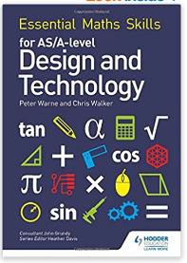
https://qualifications.pearson.com/en/qualifications/edexcel-a-levels/design-technology-product- design-2017.html
Useful Textbooks: Maths in A Level Design and Technology:
https://www.amazon.co.uk/Essential-Maths-Skills-Design- Technology/dp/1510417060

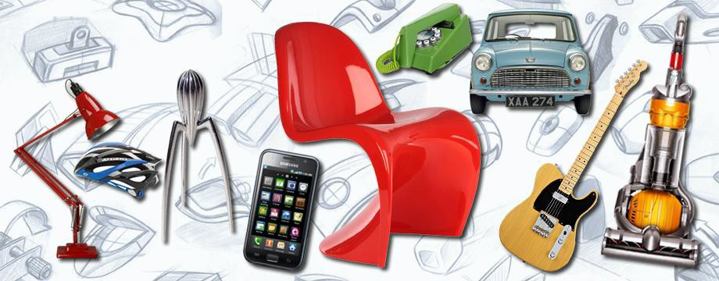

Introduction to the Product Design summer tasks:

The design industry operates on this constant desire to want to develop and improve the items we use on a day to day basis, whether this be redesigning the homes we live in, the furniture we relax on, or the technology that consumes our daily lives.



Task 1 – All About You
What is it that makes you want to pursue a design course, why are you interested in developing your design skills? This will help us understand you, your aspirations and how best to support you.
In the box below, write a short paragraph, no more than 300 words (no less than 200) explaining why you are opting to study Product Design at A Level.
Include what you believe to be your strengths and your areas you would like to work on over the course of the sixth form.

Task 2 – Inspirational Designers!
Research an Architect, designer or design firm that excites you!
What is it about their work that makes you feel inspired? In no more than 400 words introduce them, and clearly outline their key design principles. Include images you can discuss.
What makes their style unique? Select one example of their work and analyse it from both a form and function perspective.


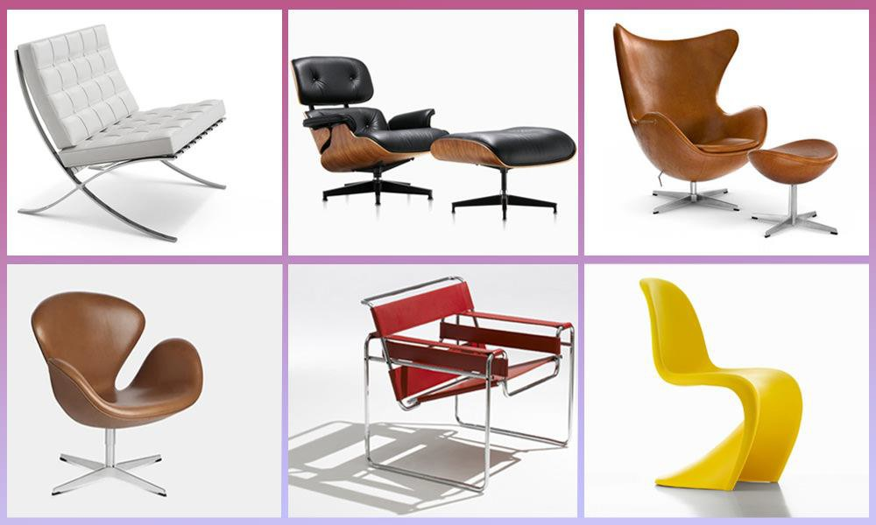

Task 3 – CAD - SketchUp
CAD = Computer aided design, love it or hate it, it’s the way we design products in modern society. You may love using CAD and be very confident in this field, fantastic! Or, you may need a little bit more encouragement and practice. Design a chair in the style of the architect you researched in task 2.
There are loads of YouTube help clips for anything you may struggle with. I have attached a tips sheet below.

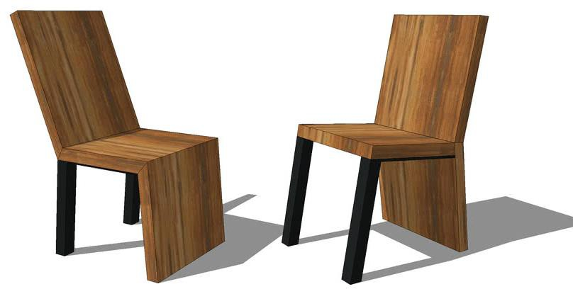
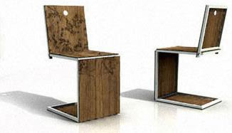
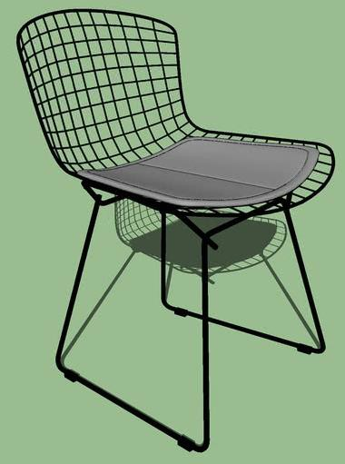

Line Tool
Select Tool r:7
Brine5 you to your arrnw tool.
I select all ace and erjge-s of
\i(l-Ur objec , ngh di(;k 011 the
.shap and se-lec:L lh.e lrori drclecl m blur;,,
Then right click aga ri and

Lets y,o11 draw :.n-a ight tiner. to create- si'tape5.
Rectangle Tool
lets 'fOI.I dr.iw sguo111"es.and Ject-.iingfes e ily.

(lrdeJo-cl
s-ele{;.the i(:□n circled i red,
2 (;apy - Se El"Ct ,.ii I fates and edge$ of )"O•Jr ol:;,ject a rid
0
( th.en pre Ctrl and C Oll 1,'Dll r b.,yooard

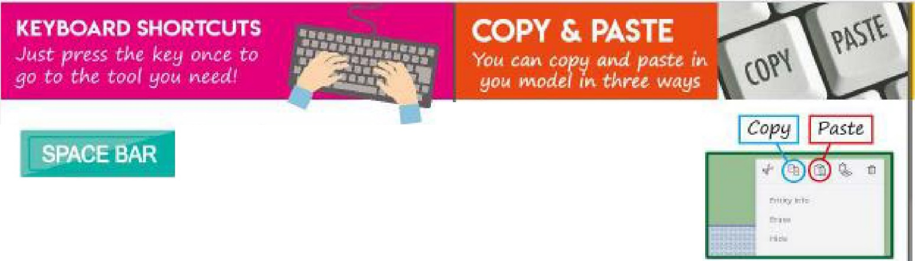

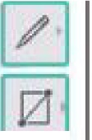
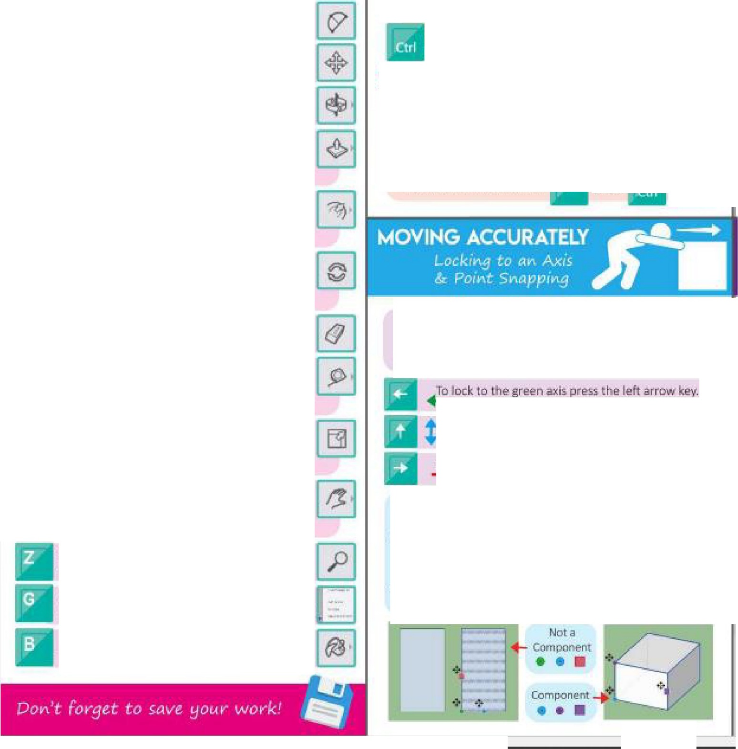


Lets ou draw drcles i:!as1ly. Just i:ll k and d g • .
ar type the·radius jhaIf the wi tn of i:he <lrde-).

Arc Tool
Lets you draw curved lines to jo,i112 po.ints:.
Move foci
Le-ts you ove the sl'lape:sy-0Ut draw.
OrbitTocl
leb yot1 cflangie tne 'o'iew of VOilr model.
rPw:hlP 11 ool
Lets yi;t>u p11Jl.yo\Jr rnodel'im:oa lD i;k1;i
from a 2:0,s.ha"
Offset Tool
Let5you cre;ite .i bigge:r or 5mo1ller Vl;!r::.1ori ,oJ your sl'tarie inside or out d12the first !J•alle.

Rotate Tbol
Let5vou rot.irte ,;mol ti.Jr.n y-ol,ir sh;ilpe-s .irntmd
their centre.
Erase Tool
Let!i ')'CIIJ era e.sl-lapes a.nd ltneSa
Tap@ Measure 'lool
Letsott m12-as-ure the ltm'gth of a line or
:i.ha .

Scale Tool
Lets v-ou make your abject bigg,er or smalter
1.1:!iin.gthe _green s.qu-:arn.s.
P°ail'I/Move Sere.en Tool
l£t5 you move the view on your wee-n wit!hQUt ctl,ms;ing the ;;i gle,

Zoom Tool
Let'su, lli.zoom in an.d'autofyour·modet
Make Component Tool
Lets you m8kea oomporier1t from your obJect.
Paint Bucket Tool
Takes y□IJ to•01,1raim: paletit;?..
at tlle same time +
Pan@ Once you have copied your Dbj@ct jus{l)rnss
Ctrl and V on your keyoo.ard
+
3 TI-le las.t and sometimes qu ic:keit way to oop,y a11
object l:s to d:o the fallowin :
- Se ect your objt!c:t th!1! pres M on your keyl:ma d
- Then hold down Ctrl on your leyooard
- Moye your mou:i;e aw rtJm the r:st obje,;;t "{_M_- -\-_
,. Th n dick! ,-
+
Now you h e-2 abje:c.ts.! thet'L ♦:.

To lack Vour Ii 1e d1re.:t1on (l ke.,,), yol.lr ot-aMn (Rkey) a
your ob]ecat movem nt (M key) to.an axis., s.elect vo1.1r
o-bjttl star MOliJf'lg It lri Chi:! diri.!C:l o ya want-and thet1:

Tn lo-r to the b ue axis press th up arrow key"

a l,:;ic to fie re-cla>:r.!; p,res.s the. rig,h ..,rrow key.

for accurat(!o mc\i'f!m11mt try to U!ie a corn r ar millp,olnL
., otComportent: Hover your mouS€ ove a oomer until .i wloured dot or S(llli'lre app,ears. Clict onc:-e and th-eri move- yqur object ti;,, whichever face 'l'i:lU wan s·ck, to.
- Ct:impof\eflt: HUilt'.!r v,our mou o...e a corhtlr unt11 a coloured dot or :square appe,ns. ic otlce afld th-en mo11e
your objec:t to whii;:he-ver f.ac:e you Wi!lntto stick it o.

•&aa&&&a&&• •••••••••••••••••••••• &&a&&&a&&&& •••
!
SELECT ON
: DoobJe dick, Tripl dick and drag to select
- ·::::·:= ; =·· ,: :-,;::"·::: --
•

select more than one obj c.t.

"/,-i
Dcubll!! dick on a "fa1ce ,md it wiII Si!!le>ct he:
Ill) imam face induding the e:dge/lir11?.
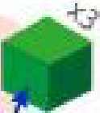
Triple. click 017 .3 face a r:id it wilI select the
entire sharp€..

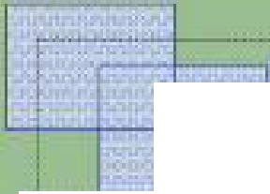
If you click ,md drng fight o left itwirl h[gti!il!lht anvrace-s a11d li11e.s it go-@s ai:;ms-.s,

If you cl"c.k.sind drag le to right it wi I! anly hp_gl,Ught full IInes, facl'!.s. and il rn .

To make part":!. aFyour model ea ier kl ma,..e .;.round you ihOl)ld< always rn.i e ·t:tiem lnto a oomPQner,t. You Cilill (lo this.lo 1. ways.
, " - · 1 Hlghhght all the faces Jitld s..ld s
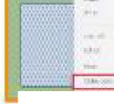
of your shape and then rish.t c:lick

2 Higl'illg
and el i;t M.ike Ctirn g11eJTt.
In the window that pops up, name
';'OIJr component arid rl1!"k OK.

h:t all thll fa,oo:;. and Sides of yaur s. p,e
and th-en pres..s G on ';'Dur .e1,tl:J.oar1i.
In e wirn::dow that pop upgi.,. your camp@ent a
llame andi c ic OI:.
RBrrtetilber, 1F yo c□p\lam::i pas e an objec yau\•e •
f
alri:::aify madE into a mm pa.nent and ry to -eha-ng12 I one, all your otller components will ch,mge tooI e
I you hav12 lots of c:ompo e-nts you want to move t0ieether you need o pu ttiem into a g,.ro p.
- fw,light ;;di the face5 ,mdide:. of vour !;f ape arr t en r f1 Cilek ani:I e-l ct Ma'k@G.roui:,.

Tod aw a
llfle or clrc
  - ick your mou ontoe
:l, "MUoJe- ','O f OU alol)g 50 that
','D r lifle U.irns-o ue, red or greer1 (IDD
- li'lartduitf1cmr Kelj'boam!
- ines-: Wlhcy11t c:lic:king <1ijain, tyi;>e

first, cl cf.: anw on the> m.ign Fylll!l gla {Ill the le bar of tools_Th1-sS!its .3t the top on its own. WP'f! Parallel P J!1C'.l1an in :.nclclick Ent /Fmturn.
Thi:in clickth na.gr ifyi ,aglas$i:'llilillin a11d t'l'P in
w lchl!vll!r of thi! followitiEI:/ .," ','Ll'IJ M:ci.1,

ym,r len!!;bh in (e.1;. 200) and pre-.ss
Ill
nt,.,r:(Return on your ki:!yboare
"'Top View
., Right View
- Bottom View " Fron.t Vie-'l't
Left View • Bad View

4. CiH:le : WtLhuul dicking a ain,
1wc- Mlf the-w oth o·vQ r orclc n.
!e.g pe- lDO ,t '(OU W3llta 200mm
•.,-cte .ircle Tti.en rire::; nter/Re \_jrr
a ybur io:e-vw.ard
:21'ffIi

Vou can also go o Scenes which is the 7th icon do•Nn on the tool bar on the rlgtii:llook IIlie fitm clapper boar'dl and dick th.e icons..l:ielow.
'" Mc.1lo:e .sure thi·scon i5 selected too


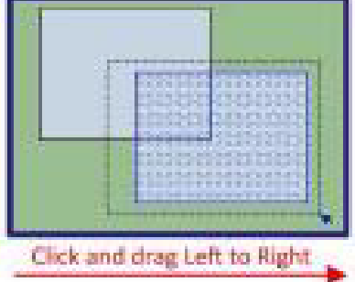
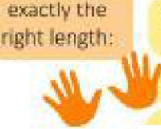
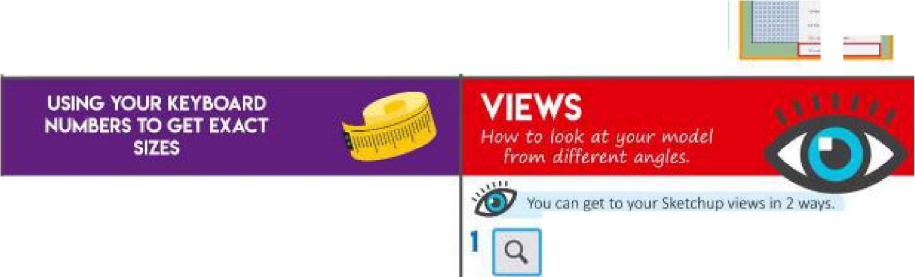



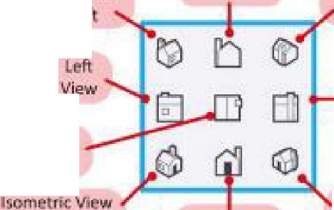
lo draw a rectangle e:.:actlv the ngh sii.c
.
-
-
I ... ·••- ····-'

- Clii.k yo '"rnolllie on,;e
- Move vour mous.e Blong so that rFr===l=I,

your line turns blue,,rei:d Of gree,11

Q. Wit m,1t i;li!;iing ;li@jn, ty_p,e one of
v,our f.arig :1. l'I-f!1:-200}, typ12 a c:.omma and then type your condl lengtti in.
Hit En er/Re um on yourlc;eybw-r-d
lsome,trit View B l<L I

Top
Vew

Front Left
Badl: ViE!W

Frm1t V w
l metrli::1/iew Bad. Right

- · bome«t-e Vit!!w
front flight

Task 4 – Upcycling!
What is it? Why is this one of the hottest trends in modern design? Using nothing but old packaging or unused products from your home, and make a high-quality model of a Product.
This could be anything, a trinket box to a lamp, a car to a decorative ornament. Carry out some research first to gain some inspirations, have a look around your house, shed, garage to see what is unused and unwanted (check with parents first!) See the inspiration below.
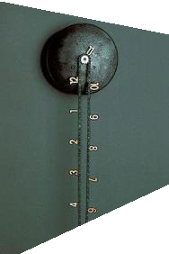
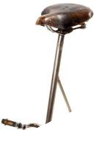
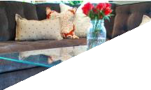
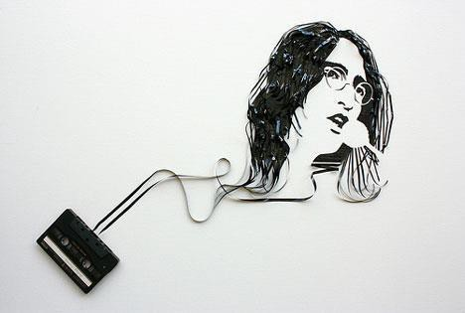
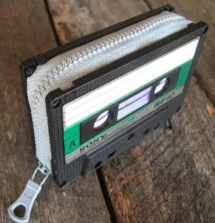
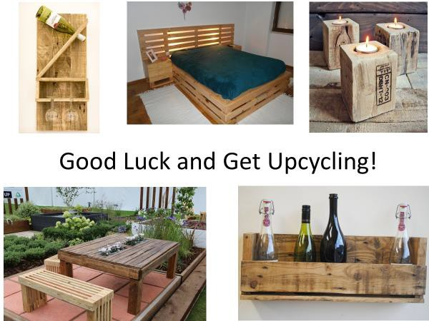

Task 5 – Isometric Sketching
Produce a high quality, hand drawn ISOMETRIC sketch of your upcycled product. Don’t worry, this is something we work on at A Level, but let’s see your skills!
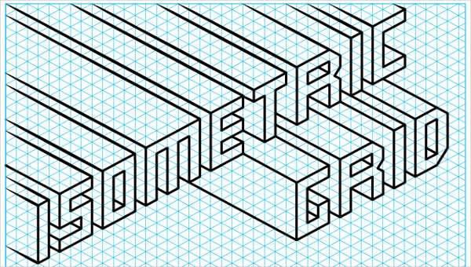
There are plenty of options of isometric grid paper online, feel free to download one and use it, if it helps at this stage!
Below is a help sheet for the more difficult shapes. These use a method called ‘crating’, where a cuboid is drawn, and the more difficult shape is then drawn inside this, making the process easier. Have a go at this.

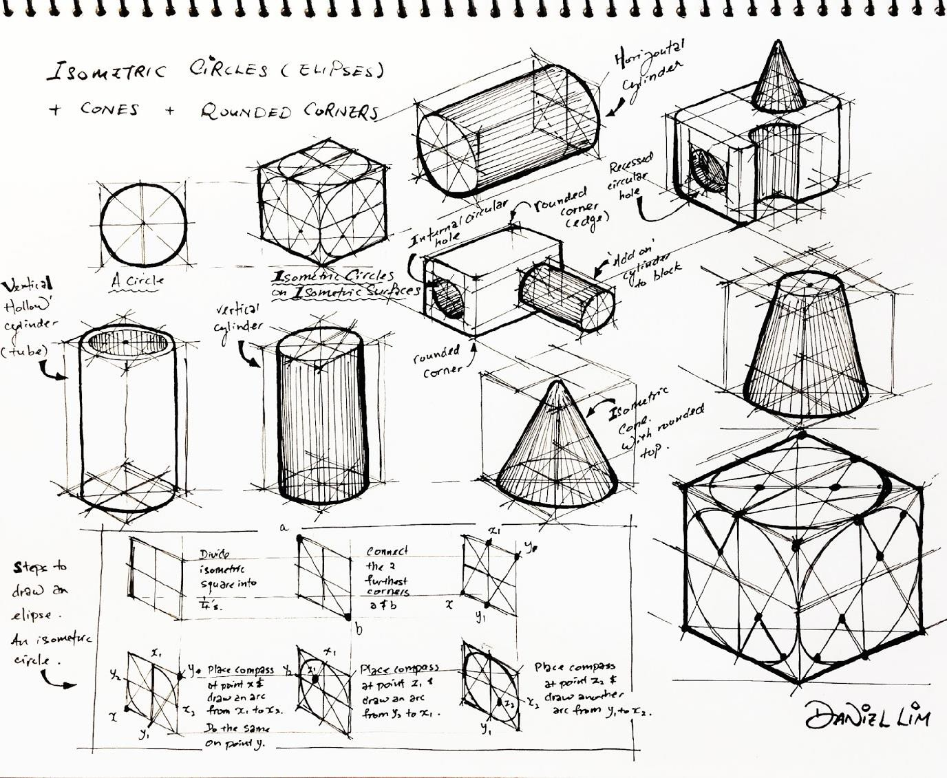

Mathematics in A Level Design and Technology
Have a look at the following Maths criteria we will be covering. Do you feel comfortable with these topics? Add ticks to the topics you are confident with and crosses to the ones you may struggle with.
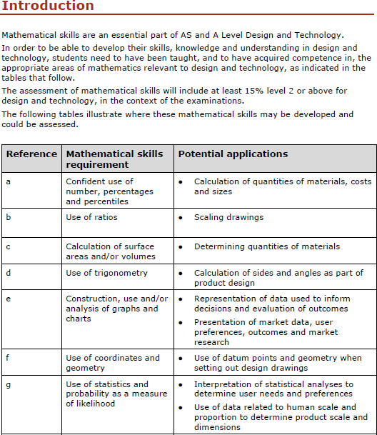

On the next page, you will find each Maths topic broken down with an explanation of how to attempt calculations for each one.

Maths skillls for AS and A Level Desi1gn and Technology

Confident use of nun1ber, percentages and percentiles
INu1nber
To convert fa-om one metric unit to armther, it is nece-Ssa ry to know the followingi:

!Length | Weight | Volume
lO mm ·- 1 cm | 1000 mg = lg | 100 d = 1 litre
100 cm = 1 m | 1000 g = 1 kg1 | 1000 mJ := 1 Ii re
lOOIJ mm = 1. m |  | 1000 om3 = 1 litre
lOOIJ m = 1 km |  | 1000 I= 1. m3

You only n1eed bo be able to mul·oiply or divide b;y 1011 100 or 1000 in 1ordei- to be able to convert betv een mebic units.
  - When conve1tingI from a sm a Iler n1JJIm ber to aI IaIrg er Irn1m1 b eIr you mu.,t remember to diviide,.

  - When conve . ingI from a bigger 111111!m1 to m 111IEtCjplly-,.
b eIr to, a s1malI er 1111111111111b,er you must remIem ber

Wh1en canying out some cornplex ea loulations, you may g1et an answei- on you - caloulator with lots of numbers, such as 125 .3 86 7
If tih1e answer was being used to measure 10u t a l1e1ni;rtih, i· wo u Id not be possible: to mark out the length to that level of aoouracy.
Certainly when measu1ing componen wi· ha micromet,er m· Vernier callipers, it is po:s:sible t,o meas.une to 2 decimal plaaes, e.g,. 26.67 mm.
We ·tiherefm-e rio u 111,d numbem to a given number 1of decimaI places,.

l .48 = 12.5 correot to 1 1decimal plaoe | Round up, because 12.48 IS doser to 12..5  than l .4
(1.0648 = 0.06 correct to 2 decimal places | Round down because IJ..0648 is closer to  0.06 than to 0.07
6. .475 = 6.248 con-ect to 3 decimal places | If the ru1gure 1n the fourth dedmal place IS  5 or more the111round[ up,

. l:a111d1a r,. form is used t,o nejpresent vieiy larg1e ( m- very :s.ma11) 111 umhers. A numb1ei- in :standan:ll fmm looks Iike this,.


5.7 X 10⁴

This pa1t is w1itten as a number b1etween 1. a1111d 10
This pa1t is written as a powe1- of 10

l | nnm = | 1 | X 101-3 mm· | uu:mo | nn
l | n,2 := 1 | X 106 mm2
l | n,2 := 1 | X 10⁴ cm

Et is import:ant to be able to nn anipuIate equations ..
To solve dem;.i· y-relaibed rques ions, we can use the follov ing equation:

' em1sillty = 1rnass
vol11111ne

Wh1en ma:s.s is mea. uned in kilogi--anns and the volume i:s,in cubic metres or m³1 the density is mea:s-'l.med in kg1per m³ or kg/nn³• Densi y can also be measured in 1g/cnn:3..

Worked exan1ple:

A 11ing has:a m,ags of 15 g.
Gold has a density of 19.3 g/om³•

Calol.llIate the volume of goldi required to make the ring.

U"'ing denisity = ma1ss
volume
this formula ca11 be rea111rangedl to ,give voll!llme = mass
denisity

15 = 0.. 777 g/om³
19.3

IPerc:e1r11tagres and pen:enti Ies
eroeITT1t:ag,e ehangie is, pe1ha pg, one of IJhie m iw;t: ronnmo:n eaIculations,.
lihe peraentage change oou Idi be an increase,. where the answe,· wou Idi be posiil:i'Ille, or a decrease, whene the answei· v ouId be negatiwe.
To eaIculaibe percentage ehang1e1 the follow ing1equation ea n be used :

final data set -initial da:ta set)x] 00 inihal data &et
(

So I i·f the initi aI dlata set is 22 and the fiina I data :set is 40 1 then the percentage dha nge is:

4o- 22Ix HICI = (1 8 x 100 = 81..8% (or &2%)
( 22 ) . )
22.

Worked example:

A mallliufacturi111g aompa ny has:moved to a 111,ew fa ctoI1y.
Th,e o!ld factory was: 8000 m2 and the new faotof)I' is 11500 m2,. Callol.llate the percentage inorea.s,e in floor space.
U51JO - 8000 x 100 = 43. 75% (or 44%)
801)0

Worked example:

Th,e mass of a casting is redluced by 8 % dlue to ma ehining,. Th,e o:ni,gi nal cas:llin g weighs 3,.65 kg.

Callol.llate he final weight of he casti111,g once it has be,en m,a,chinedl.

Method 1
8% Of 3.65 = 8 X 3.65
100
= 0.2.92 g [ he 8% 1red1..1otion is 0.2.9 g]

3.65 - 0,.292 = 3.358 kg [s:ubtract it to work out the final weii,ght]

Method 2
100% - 8% = 92% [the final vallue is 92.% of the miginal weight]

92.% = 92 = 0.92 [0,.92 is tlh,e multiplier]
100

0.92. x 3,.65 = 3.358 kg [multiply the o,riginal weight by 0,.92]

Com pound peroenta g,e inoreases a re oft:,en us:edl by cornpanies to p,roj,ect:· uture oosts such as sitaff salaries m· maoe iials aos.ts,.
If materials cos: a ·-e es:timatedl t,o rise at 3% a year for tlhe lfTi,ext three years, oomp,ani ea n eaIculate tlh,ei r materiaI.. oosts using compound interest ealculations.

Year | Amount at the start of the year | A1nount plus interest | Total amount at the,end of the y·ear
l | £rno,,ooo, | um,ooo X L03 | £103,000
2 | £1.03,000r | 1113,000 X L03 ·- 100,000 X 1,.032 | £106,0'90
3 | £1.05,0901 | 106,090 X l,.i)3, ·- 100,000 X 1,.033 | £109,272,.70

Use of rc1t·os
atllos are u:gedl to oom pa re rqu an i ies. Tihe s m pies ifmTil olf a ra- io has a whol1e 11umber with no commo:nifactor""r e.. g. 1:3
atiios are often 1gi'lllen in the form 1:n where n is a number.
lihi:s.fo T11 olf ratio_{I} the um1ita ry ratio, i:s.most ofiben used for .§leaIe 1drawing:s.olf thing Iike buildings or for maps,.
To w,ite a ratio in the orm of 1.:n divid1e ea eh number in the ratio by the firnt: 11umber in that: 1-.3·1:Jio.
fm· example,. 5:16 = =16

5 5
= 1.:3.·

Cc1lcullation of su rfc1ce are;as and/ or volun1es
Many v ooden l:Joys suclri as. train"' and building blocks. are made up a · combinatiorm olf re,gular .solid geom e ric shape..s"'.ueh as cuboid.s., cylindler:s and p1isms.
So tlhat manufaoturens can work out how mudh timber to buy andl, indeedl,. consid,er the mo:gt eronomicaI form of timber to buy,. it is important that tlhey are abIe to ra lculat:e ViOIum es,.lihe cal uIation olf su tfare area is also imp mta nt so that manufac uner-s can eaIcula e the volume o · su1face · mishes., for IexampIe.
lit: is also important for oomp,an ies l:Jo be able to consider ViOIumes when packaging items. lif a manu c11cl:Juring company is "'.hipping lap op:"'., they need to be abIe to convert:between units af 'i.i'iolumes wh1en th1ey package smaller bol<Jes into lang,e1· boxes·m IJransportalJion. Sometimes even shipp ingI rontainer V1OIumes have to be con"'ideredl ito ensure ma:ximum use is made af · he available volume when moving1g1oods lfirom one country to another.
linsert: a dliag1c1m olf volume and surfooe a -ea formula for: oube_{I} cylindleri h1emis.phe11e a111d "'phere. ake sure o oove1· cir-cum lference andi area of a circle.

Use of trigonon1etry
Trig1onometry i:s.used extensively in the world of iteclrinolog1y and engineeiin1g,.It: is. used to calouIate · he paths a111d movements af robot:s and automated guided veh ides ( A!GVs) within footorieg. Pythagimas" theorem is. also used to calculate he lengrl:Jhof "".id:e..s. of a right-angled triangle, 01· fo1· checking that a righ -angled triangle has been marked ou corneotl''l with a 90° angIe.
lihe longest sidle of a right-angled triangle is. k111orv n a,g. the lhyp,o;lltenl!J1se (hyp) and is aIways opposite the right: angle. The nemaining two sides are known as the op,posite (opp) a111d adjacent {adj)i as shown in Figure, ..


opp
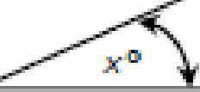
a.dj

Figllllr.e 1

Trig1onome ry can al:so be u:sed to calculate the anrgles, of joints. when manufacturiing pm d um. Fn ·ilire:s,e cases, we ne,ed to be able to app Iy anrd use ·ilire s n,e and ,c:osi Iii e of a11g1lres.
En fiig11r1e1 2.r we c-an u:s,e thesinre and cosi11 e of the angle to eaIculaibe the u11 known lengths af ·ilire triangle.
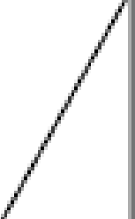

4

4sin6Ql!o

4cos60°
F"glll.lr,e 2

The length of the opposite can be calculated by 4 x sin&o0 or 4-""in6o,0 The length of the ardjaoe nt c-an be c-al uIated by 4 x co.s.6(f1 or 4cos60°
En ·ilire revent that thre lreng1h of the hypotenuse is u11k11own1 the opposite and adj oen ea11 be eaIeulated using the follrowing foimuIa e::

sin60⁸ = QRQ.
hyp
and oo·"'.6'0,°= adlii
hyp

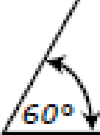
Howeve,·.rthese nuIe .are onIy true for rig1ht-anrgIedbianrgIe .•
Whren the opposite side a11 di the adjaoent side a ·-e involved:

Tan&0° := .Q!Q!1!
ardj

The a crro n ym ·0• H CAHTOA might help you to re mre mber these fornnulae:

Sin Opp Hyp Cos Adj "IP Tan Opp Adj

Constrl ction, use and/or anal·ysis of graphs and charts
Graph""a11 di charts a re a verv popular a11 di effic,irent nn ethod of reiPresenting a g -ea· deal of infro1mation and data,. Various cha :s anrd graphs a re used I suoh as bar oha rts pie cha, "' a11 di hi:stog11c1nns..
User's needs . prefenenoe:s.and views are often canvassed as part:of the research p1-ooess1 with the resu I· bei11 g1represented in a g □ phirea I · o rm.



Bar oharts: are IJlss:ed to 1-epresen1t gmup!!ed data, 1J1ss:mg rectangula - bars with va.-ying lengths, p1-opott0i 11a1I t,Q the 'IlaIues:·!Jhat ·1:Jh ey represent. B.a rn can hie p Iotted v,e tieally or horizontaIly, in 20 m· 3D. Wit'lll a v,atically plotted bar chart,. the vert:Dcal axis wi11be used
·ro repr-e e111It a numerical value a111d the lrn,ars IJlcSed to ide111tify a .specific categoiry.
Fiig1111re 3 shows a ba,· chatt indi,cating the height of a num Im elf of trees at were planted on the samn,e day in a manag:ed forest. Thi,g:type of graph might mie us,ed to analyse: growl:Jln ra'tr.es: or bJ ide1111tify the: 111 umber- of trees b,efow a ae ain heig hit that l1lil i ght need to be:felled1 tine:reby alIowing the remainin,g b-ees ,greater aoaess to Iight an,d wat,e - and nu'li:rients i11·1:J'llle soil..

TmHetghts
50 -
40
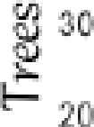 -
-

0 .--

100 150 200 250 300 350
lietght cm

Figur.e.3

Pie cbairt.s
ie: c'lllarts are: ano!Jhelf pop!!ular me:!Jhod to re:presen1t data. They ca11e1asily hile ,ge11elfated in programns such as Microsoft:® ,excel.
Thew,ole oim1e represents the total n1J1mnber ,of items m·resp!lonses. Tine. siize of a sect,olf will be a pilf,opllrtion of the t,otal frequency .. Th,e. angles at the ( entre of the pie ohart must add up to 3600.
The an le. fo - eadin sectm- can b,e. fou n ol using the. foll,owing formnIJl la:

seotrnr a111 gle = fregu,ency x 360 O
to'li:aI frequency

T,able 1 shows the nunr1hilelf o,fow111ers of mnobil,e pho111e:s,and Fiigure. 4 slhow:s the same data i111 !Jh,e fom, of a pi,e oha,t,.

IPl110111e

INt1111ber

iPhone 6

.38

iPhcrme: 7

26

Samsung1S.8

15

Samsm1g1 Galaxy eol g:e:
13

Nokria X1

8

Tab e I

Mobile, none owne, s
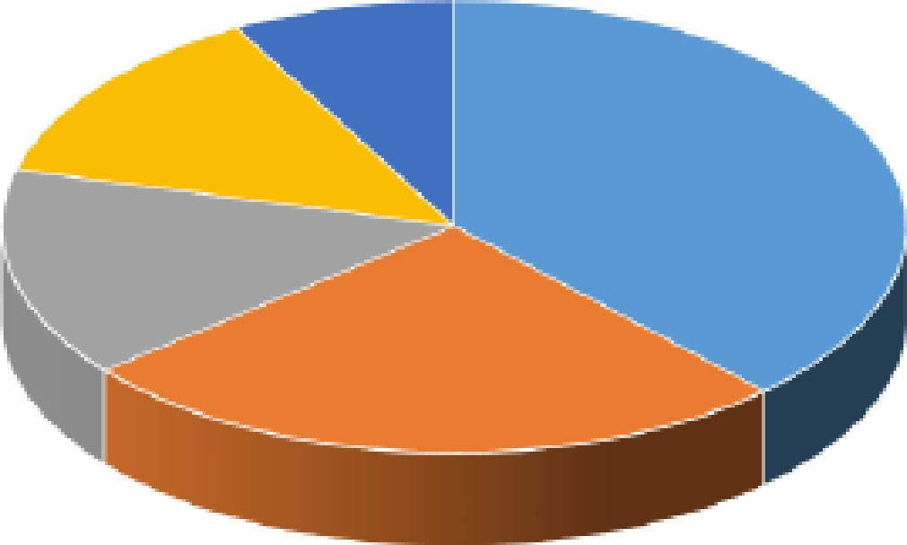

., IPhone 6 • iF"l'IMe 7 • samsuns SS • sams G:c1laxv Ed ■ Nokia Xl

Figure 4

Total fr,eq1J1e111cy = .38 + 215 + 15 + 13 + 8 = 100

iPh,one 6 = .38 x: 3150,o = 136,.8°
1.00

Once all of ·l:Jli1e fr,eque11cies haveeen Gak1J1lat,ed yousncmld cheok that all ·ilie anrgles: add up t:o .3600.

Hilstogran s,
,A n ist,og!fa m ios used to represe1111t ao11'111r1iuous data SIJIdn as a nrt'hmpi1onnebic data, e,.g. ilrhe heights o:f studenrts i111 yo!JI r ali3'88. Cmrnti nuous ,dailrann ea ns ·the re are no g1aps between thre bars.

count
a .

0 I
1-0
l
150


170 100

Fig11.1re.:5
So ro tllpis;f)'www_siy=1.Jl:1,;oomJm:1tbs:f ·!!:-11[11-st::i'iiirti1:s:[l:ilap.:ici:1IT•B/"111!:l!l;ili'47646:1Jb,d!Jl254;:i 71i45:1,91 ,!;

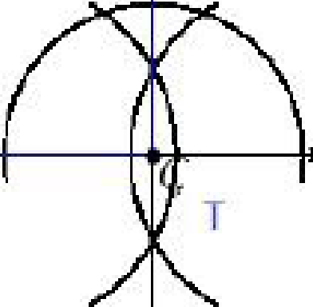
se of coord-Hiltes and geon1etry
,A dab.Jm ref'e,relllioe poirnt icSIJlcSed when marking OIJlit rdu ring man1J1Jf:actu ri111 g1proce.sses. It is a singlemi1111t from whioh all mneasmnernrooil:s anc:.1rakJern or f]Dints marked out,.
easuremenll:s woul,d be rgivern in mnnn, onn or mn dlependinrg 011·1:Jlne. saal,e. anid si2!e of the o :eat beinrg marlred out.
On some occasiionsir it is neces.sa ry to mark rout greom ebll"ic sh.api! es SIJel h as sq u.ar,es and tttianrgles. Tlner,e. are three rdiiffonent tyjp,es of triangle5ir but ilrhey can all be constrnctred
wit:h a oom passr given the side lengths. Thre O(!iffipi!•ass i,s:.set::t,(!i tlhre lrenrg't:h requirred anid thie11U1cSed to draw amarc. The sides of"lilne.biangle can e drawrn w,em the arcs inter:s,eci:.

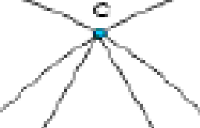

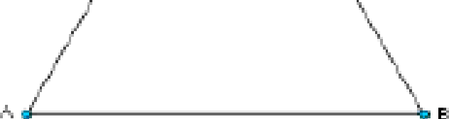
FigllllN!! 6

m fig1111re 16,, 1:J'he triangle.is an i:s'O!sceles 1:Jll"iarngle:: 1:Jlnis means !Jhat all lthree:sidle_s:arre e!Jlual in lerngrl:Jln. t also means that the thr,,e,e irnternal anrgles are equal at 600, there: being a totaI of l.aooi 111 a nv bianrgIe.
,A s.quare:rof t:he knowrnside length can also be oo:nstructed 1J1,Sing a compass, since: iit is po.s.siblre t,o cr,eat,e a go,oright-angl,e.by biseoting a sbaigh line (w1nioh is essentially an rno;Oangle:).. This is shown i11I1Fiig1111re 1·.

V
u

5 Square

FigllllN!! 7

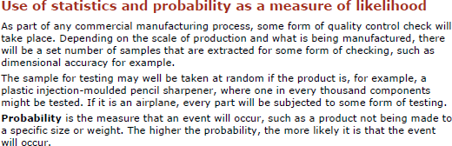

Send your completed tasks to Mrs Burdett gburdett@phs.cheshire.sch.uk
I can’t wait to see them!

See you in September
😊

