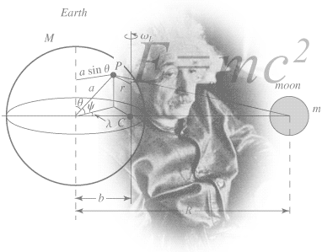

Considering
A Level Physics?

Figure 1 http://scienceworld.wolfram.com/physics/images/main-physics.gif
This pack contains a programme of activities and resources to prepare you to start an A Level in Physics in September. It is aimed to be used throughout the remainder of the Summer Term and over the Summer Holidays to ensure you are ready to start your course in September.
Contents – Items in Bold are Compulsory
P2 Ideas for Virtual Day Trips
P2 Book Recommendations
P4 Series/Video Clips Recommendations
P5 Movie Recommendations
P6 Research Activity
P7 Pre-Knowledge Topics (reinforcement before September)
P8 Pre-Knowledge Topics - Answers

Ideas for Virtual Day Trips

Here are some suggestions for some physics-themed virtual excursions

https://home.cern/resources/360-image/accelerators/virtual-tour-lhc

https://www.nasa.gov/nasa-at-home-virtual-tours-and-augmented-reality

https://interestingengineering.com/11-science-and-tech-museums-you-can-tour-virtually
https://www.weareteachers.com/best-virtual-field-trips/
https://www.discoveryeducation.com/community/virtual-field-trips/

Book Recommendations
There is so much for you to find on the internet, e.g. https://www.thoughtco.com/interesting-and-weird-physical-ideas-2699073
There are also lots of fantastic full-length books available for an introduction to science in an accessible way. These are some I have enjoyed reading.

- Surely You're Joking Mr Feynman: Adventures of a Curious Character
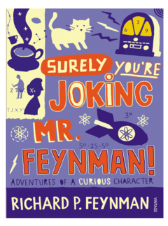
Richard Feynman was a Nobel Prize winning Physicist. I have always had a Physics Crush on him! By reading his books you will get a taste of his his bongo-playing adventures and eye for the ladies, as well as insight into his life’s work including the creation of the first atomic bomb and ground-breaking work in the field of particle physics. (Also available on Audio book).
Further Feynman:
- What Do You Care What Other People Think?: Further Adventures of a Curious Character
- The Pleasure of Finding Things Out
- Six Easy Pieces: Essentials of Physics Explained by Its Most Brilliant Teacher

Have a look at this 50 min doc too: https://www.bbc.co.uk/iplayer/episode/p018dvyg/horizon-19811982-the-pleasure-of-finding-things-out

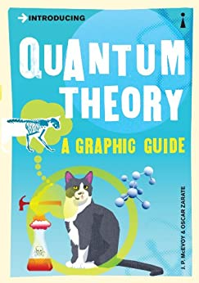
Introducing Quantum Theory: A Graphic Guide

This Graphic Guide series is amazing and if you have Kindle Unlimited all are FREE! Do beware, it can be difficult to read the speech bubbles on a small screen … although you might be ok with young eyes!

How to Teach Quantum Physics to Your Dog
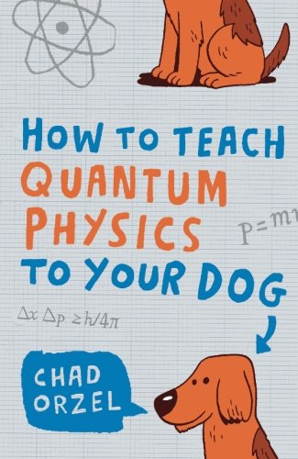

A fun approach – the author uses his dog’s crazy behaviour as a starting point to describe and discuss some of the bizarre behaviour of the quantum world.

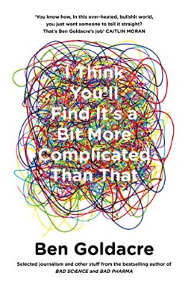

Bad Science and/or I Think You’ll Find It’s a Bit More Complicated Than That

I LOVE Goldacre! He is a medically trained journalist who does a great job not only debunking woo but in making us think more clearly about what evidence means and what evidence we require as a society before decisions are made that affect us all.

If you are thinking of studying Chemistry or Biology, Bad Pharma is also great.

Thing Explainer: Complicated Stuff in Simple Words

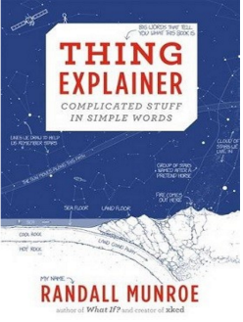
I love the comic XKCD. It was introduced to me a few years ago by a student I taught for Psychology A Level. This book by the comic’s author uses only the 1000 most common words in the English language to explain the structure and function of lots of “Things”, from simple everyday objects such as a biro to the Saturn V rocket and an atom bomb.

Series / Video Clips Recommendations

Minute Physics – Even if you only have a couple of minutes you could find out something with this series. A huge variety of Physics questions are explained simply (in felt tip!) in a couple of minutes. https://www.youtube.com/user/minutephysics

Cosmos – A reboot of the seminal 1980 original which featured Carl Sagan (“Somewhere, something incredible is waiting to be known”). Neil deGrasse Tyson traces our roots back to the hearts of ancient stars, and takes us on a journey across the universe for a vision of the cosmos on the grandest scale.

No longer on Netflix, but I think it is on the new Disney+ service. Also found elsewhere e.g. https://www.dailymotion.com/video/x35e2io

Shock and Awe, The Story of Electricity – Mrs Pitt’s favourite science presenter, Jim al Khalili’s 3 part BBC documentary is essential viewing if you want to see how our lives have been transformed by the ideas of a few great scientists a little over 100 years ago. Spoiler: Edison was an absolute rotter!

This link has all three episodes in one massive video – I recommend an episode at a time! https://www.youtube.com/watch?v=Gtp51eZkwoI

The Biggest Ideas in the Universe – simple format, Sean Carroll and a felt tip. Much better than it sounds, as Sean Carroll is ace. Lesson 1: Conservation; Lesson 2: Change … Just watch out for him calling kinetic energy a vector in a slip of the tongue when describing the scalar addition of kinetic energy. He very much does know what he is talking about, don’t worry! Quite good website/blog too.
http://www.preposterousuniverse.com/blog/2020/03/24/the-biggest-ideas-in-the-universe-1-conservation/

NASA TV – Online coverage of launches, missions, testing and the ISS. Plenty of clips and links to explore to find out more about applications of Physics in Space technology.

http://www.nasa.gov/multimedia/nasatv/

The Fantastic Mr. Feynman – Cannot ignore the fantastic Mr Feynman.
https://www.youtube.com/watch?v=H9fjhQMsDW4

Movies Recommendations

Disclaimer – I stole this list from the internet! You should also try to see Apollo 11 (2019) – remastered footage from the 1969 Moon landing mission.

The Martian
This film, based on the debut novel by Andy Weir, tells the story of an astronaut injured and accidentally stranded alone on the planet Mars. In order to survive long enough to be rescued, he must leverage every resource with scientific precision.

Gravity
Sandra Bullock plays an astronaut whose spaceship is damaged by meteorites, leaving her in a desperate race adrift in space as she attempts to reach safety and find a way home. Though the credibility of some of the action sequences is a bit strained, the way they handle her movement in space and the planning she has to make to get from location to location is well worth it from a science standpoint. The film the visually stunning.

Apollo 13
In 1970, astronaut Jim Lovell (Tom Hanks) is commanding a "routine" mission to the moon. With the famous words "Houston, we have a problem," begins a terrifying true journey of survival, as the three astronauts attempt to survive in space while scientists and engineers on the groundwork to find a way to bring the damaged spacecraft back to Earth safely.
Apollo 13 retains scientific integrity in exploring this significant moment in the history of space travel.

October Sky
This film is based on a true story about a teenager (Jake Gyllenhaal) who becomes fascinated with rocketry. Against all odds, he becomes an inspiration for his small mining town by going on to win a national science fair.

The Theory of Everything
This film tells the story of the life and first marriage of cosmologist Stephen Hawking, based on his first wife's memoir. The film does a decent job of portraying the difficulties that Dr. Hawking faced in developing his groundbreaking theories, e.g. Hawking radiation and explaining the theories in general terms.

The Abyss
The Abyss is a fun film, and though more science fiction than science fact, there's enough realism in the portrayal of the deep sea, and its exploration, to keep the physics fan quite interested.

Infinity
Infinity is the film telling the story of young Richard P. Feynman's marriage to Arlene Greenbaum, who suffered from tuberculosis and died while he worked on the Manhattan Project in Los Alamos. It is an enjoyable and heart-tugging tale, though Broderick doesn't do full justice to the depth of Feynman's dynamic character, in part because he misses out on some of the more enjoyable "Feynman stories"

2001: A Space Odyssey
“My God, it’s full of stars!” 2001 is the definitive classic space film, considered by many to have ushered in the era of space action special effects. Even after all these years, it holds up quite well. If you can deal with the pacing of this film, which is a far cry from the whiz-bang of modern science fiction films, it's a great film about space exploration.

Interstellar
This is perhaps something of a controversial addition to the list. Physicist Kip Thorne helped on this film as a science advisor, and the black hole is basically handled well, in particular, the idea that time moves radically differently as you approach the black hole. However, there are also a lot of bizarre story elements within the climax which really make no scientific sense, so overall this one may be considered something of a break-even in terms of scientific validity.
Research activity
To get the best grades in A Level Physics you will have to get good at completing independent research and making your own notes on difficult topics. Below are links to 5 websites that cover some interesting topics.
Using the Cornell notes system: http://coe.jmu.edu/learningtoolbox/cornellnotes.html make 1 page of notes from each site covering a topic of your choice.
- http://home.cern/about
CERN encompasses the Large Hadron Collider (LHC) and is the largest collaborative science experiment ever undertaken. Find out about it here and make a page of suitable notes on the accelerator.
- http://joshworth.com/dev/pixelspace/pixelspace_solarsystem.html
The solar system is massive and its scale is hard to comprehend. Have a look at this award winning website and make a page of suitable notes.
- https://phet.colorado.edu/en/simulations/category/html
PhET create online Physics simulations when you can complete some simple experiments online. Open up the resistance of a wire html5 simulation. Conduct a simple experiment and make a one page summary of the experiment and your findings.
- http://climate.nasa.gov/
NASA’s Jet Propulsion Laboratory has lots of information on Climate Change and Engineering Solutions to combat it. Have a look and make notes on an article of your choice.
- http://www.livescience.com/46558-laws-of-motion.html
Newton’s Laws of Motion are fundamental laws for the motion of all the object we can see around us. Use this website and the suggested further reading links on the webpage to make your own 1 page of notes on the topics.
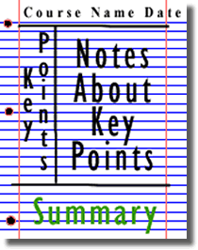

Figure 2: http://coe.jmu.edu/learningtoolbox/images/noteb4.gif

Pre-Knowledge Topics
Below are ten topics that are essential foundations for you study of A-Level Physics. Each topics has example questions and links where you can find our more information as you prepare for next year. In September, our baseline test will be based on these ten topics.
Prefix | Symbol | Power of ten
Nano | n | x 10⁻⁹
Micro | μ | x 10⁻⁶
Milli | m | x 10⁻³
Centi | c | x 10⁻²
Kilo | k | x 10³
Mega | M | x 10⁶
Giga | G | x 10⁹
Symbols and Prefixes

At A level, unlike GCSE, you need to remember all symbols, units and prefixes. Below is a list of quantities you may have already come across and will be using during your A level course
Quantity | Symbol | Unit
Velocity | v | ms⁻¹
Acceleration | a | ms⁻²
Time | t | S
Force | F | N
Resistance | R | Ω
Potential difference | V | V
Current | I | A
Energy | E or W | J
Pressure | P | Pa
Momentum | p | kgms⁻¹
Power | P | W
Density | ρ | kgm⁻³
Charge | Q | C

Solve the following:
- How many metres in 2.4 km?

- How many joules in 8.1 MJ?

- Convert 326 GW into W.

- Convert 54 600 mm into m.

- How many grams in 240 kg?

- Convert 0.18 nm into m.

- Convert 632 nm into m. Express in standard form.

- Convert 1002 mV into V. Express in standard form.

- How many eV in 0.511 MeV? Express in standard form.

- How many m in 11 km? Express in standard form.

Standard Form
At A level quantity will be written in standard form, and it is expected that your answers will be too.
This means answers should be written as ….x 10^{y}. E.g. for an answer of 1200kg we would write 1.2 x 10³kg. For more information visit: www.bbc.co.uk/education/guides/zc2hsbk/revision

- Write 2530 in standard form.

- Write 280 in standard form.

- Write 0.77 in standard form.

- Write 0.0091 in standard form.

- Write 1 872 000 in standard form.

- Write 12.2 in standard form.

- Write 2.4 x 10 ² as a normal number.

- Write 3.505 x 10 ¹ as a normal number.

- Write 8.31 x 10 ⁶ as a normal number.

- Write 6.002 x 10 ² as a normal number.

- Write 1.5 x 10⁻⁴ as a normal number.

- Write 4.3 x 10³ as a normal number.

Rearranging formulae
This is something you will have done at GCSE and it is crucial you master it for success at A level. For a recap of GCSE watch the following links:
www.khanacademy.org/math/algebra/one-variable-linear-equations/old-school-equations/v/solving-for-a-variable
www.youtube.com/watch?v=_WWgc3ABSj4

Rearrange the following:

- E=m x g x h to find h

- Q= I x t to find I

- E = ½ m v² to find m

- E = ½ m v² to find v

- v = u + at to find u

- v = u + at to find a

- v² = u² +2as to find s

- v² = u² +2as to find u

Significant figures

At A level you will be expected to use an appropriate number of significant figures in your answers. The number of significant figures you should use is the same as the number of significant figures in the data you are given. You can never be more precise than the data you are given so if that is given to 3 significant your answer should be too. E.g. Distance = 8.24 m, time = 1.23 s, therefore speed = 6.75 m/s

The website below summarises the rules and how to round correctly.
http://www.purplemath.com/modules/rounding2.htm

Give the following to 3 significant figures:

- 3.4527
- 40.691
- 0.838991
- 1.0247
- 59.972

Calculate the following to a suitable number of significant figures:

- 63.2/78.1
- 39+78+120
- (3.4+3.7+3.2)/3
- 0.0256 x 0.129
- 592.3/0.1772

Atomic Structure
You will study nuclear decay in more detail at A level covering the topics of radioactivity and particle physics. In order to explain what happens you need to have a good understanding of the model of the atom. You need to know what the atom is made up of, relative charges and masses and how sub atomic particles are arranged.

The following video explains how the current model was discovered www.youtube.com/watch?v=wzALbzTdnc8

Describe the model used for the structure of an atom including details of the individual particles that make up an atom and the relative charges and masses of these particles. You may wish to include a diagram and explain how this model was discovered by Rutherford

Recording Data
Whilst carrying out a practical activity you need to write all your raw results into a table. Don’t wait until the end, discard anomalies and then write it up in neat.
Tables should have column heading and units in this format quantity/unit e.g. length /mm
All results in a column should have the same precision and if you have repeated the experiment you should calculate a mean to the same precision as the data.

Below are link to practical handbooks so you can familiarise yourself with expectations.

http://filestore.aqa.org.uk/resources/physics/AQA-7407-7408-PHBK.PDF
http://www.ocr.org.uk/Images/295483-practical-skills-handbook.pdf
http://www.ocr.org.uk/Images/295483-practical-skills-handbook.pdf

Below is a table of results from an experiment where a ball was rolled down a ramp of different lengths. A ruler and stop clock were used.

1) Identify the errors the student has made.

 | Time
Length/cm | Trial 1 | Trial 2 | Trial 3 | Mean
10 | 1.45 | 1.48 | 1.46 | 1.463
22 | 2.78 | 2.72 | 2.74 | 2.747
30 | 4.05 | 4.01 | 4.03 | 4.03
41 | 5.46 | 5.47 | 5.46 | 5.463
51 | 7.02 | 6.96 | 6.98 | 6.98
65 | 8.24 | 9.68 | 8.24 | 8.72
70 | 9.01 | 9.02 | 9.0 | 9.01

Graphs

After a practical activity the next step is to draw a graph that will be useful to you. Drawing a graph is a skill you should be familiar with already but you need to be extremely vigilant at A level. Before you draw your graph to need to identify a suitable scale to draw taking the following into consideration:

- the maximum and minimum values of each variable
- whether 0.0 should be included as a data point; graphs don’t need to show the origin, a false origin can be used if your data doesn’t start near zero.
- the plots should cover at least half of the grid supplied for the graph.
- the axes should use a sensible scale e.g. multiples of 1,2, 5 etc)

Identify how the following graphs could be improved

Graph 1 Graph 2
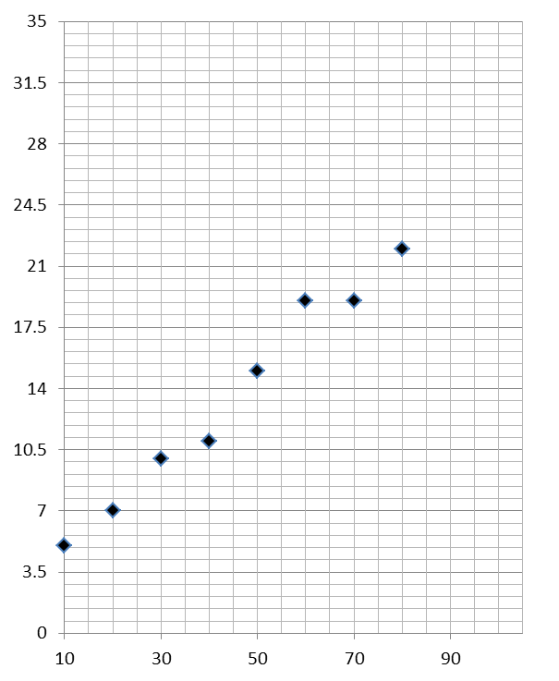

Forces and Motion
At GCSE you studied forces and motion and at A level you will explore this topic in more detail so it is essential you have a good understanding of the content covered at GCSE. You will be expected to describe, explain and carry calculations concerning the motion of objects. The websites below cover Newton’s laws of motion and have links to these in action.

http://www.physicsclassroom.com/Physics-Tutorial/Newton-s-Laws
http://www.sciencechannel.com/games-and-interactives/newtons-laws-of-motion-interactive/
Sketch a velocity-time graph showing the journey of a skydiver after leaving the plane to reaching the ground.
Mark on your graph the region where he is travelling at terminal velocity.

Electricity
At A level you will learn more about how current and voltage behave in different circuits containing different components. You should be familiar with current and voltage rules in a series and parallel circuit as well as calculating the resistance of a device.

http://www.allaboutcircuits.com/textbook/direct-current/chpt-1/electric-circuits/
http://www.physicsclassroom.com/class/circuits

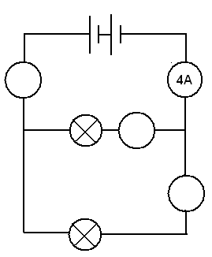
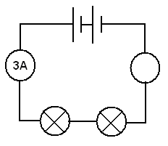
1a) Add the missing ammeter readings on the circuits below.

b) Explain why the second circuit has more current flowing than the first.

2) Add the missing potential differences to the following circuits
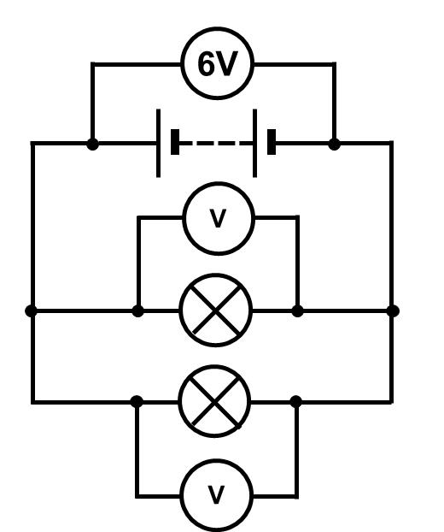
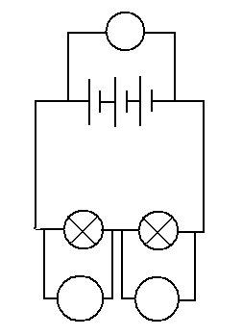
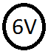

Waves
You have studied different types of waves and used the wave equation to calculate speed, frequency and wavelength. You will also have studied reflection and refraction.
Use the following links to review this topic.
http://www.bbc.co.uk/education/clips/zb7gkqt
https://www.khanacademy.org/science/physics/mechanical-waves-and-sound/mechanical-waves/v/introduction-to-waves
https://www.khanacademy.org/science/physics/mechanical-waves-and-sound/mechanical-waves/v/introduction-to-waves

1) Draw a diagram showing the refraction of a wave through a rectangular glass block. Explain why the ray of light takes this path.

2) Describe the difference between a longitudinal and transverse waves and give an example of each

3) Draw a wave and label the wavelength and amplitude

Pre-Knowledge Topics Answers:
Symbols and prefixes
- 2400
- 8 100 000
- 326 000 000 000
- 54.6
- 240 000
- 1.8 x 10⁻⁸
- 6.32 x 10⁻⁷
- 1.002
- 5.11 x 10⁻⁵
- 1.1 x 10⁴

Standard Form:
- 2.53
- 2.8
- 7.7
- 9.1
- 1.872
- 1.22
- 2400
- 35.05
- 8 310 000
- 600.2
- 0.00015
- 4300

Rearranging formulae
- h= E/ (m x g)
- I = Q/t
- m = (2 x E)/v² or E/(0.5 x v²)
- v= √((2 x E )/m)
- u = v – at
- a = (v-u)/t
- s = (v² – u²) / 2a
- u = √(v²-2as)

Significant figures
- 3.35
- 40.7
- 0.839
- 1.02
- 60.0
- 0.809
- 237
- 3.4
- 0.00330
- 3343

Atomic Structure
contains protons, neutrons and electrons
Relative charge:
protons are positive (+1)
electrons are negative (-1)
neutrons are uncharged (0)
Relative mass:
proton 1
neutron 1
electron (about) 1/2000
protons and neutrons make up the nucleus
the nucleus is positively charged
electrons orbit the nucleus at a relatively large distance from the nucleus
most of the atom is empty space
nucleus occupies a very small fraction of the volume of the atom
most of the mass of the atom is contained in the nucleus
total number of protons in the nucleus equals the total number of electrons orbiting it in an atom

Recording data
Time should have a unit next to it
Length can be measured to the nearest mm so should be 10.0, 22.0 etc
Length 65 trial 2 is an anomaly and should have been excluded from the mean
All mean values should be to 2 decimal places
Mean of length 61 should be 6.99 (rounding error)
Graphs
Graph 1:
Axis need labels
Point should be x not dots
Line of best fit is needed
y axis is a difficult scale
x axis could have begun at zero so the y-intercept could be found
Graph 2:
y-axis needs a unit
curve of best fit needed not a straight line
Point should be x not dots
Forces and motion
Graph to show acceleration up to a constant speed (labelled terminal velocity). Rate of acceleration should be decreasing. Then a large decrease in velocity over a short period of time (parachute opens), then a decreasing rate of deceleration to a constant speed (labelled terminal velocity)
Electricity
1a) Series: 3A, Parallel top to bottom: 4A,2A,2A
b) Less resistance in the parallel circuit. Link to R=V/I. Less resistance means higher current.
2) Series: 3V, 3V, Parallel: 6V 6V

Waves

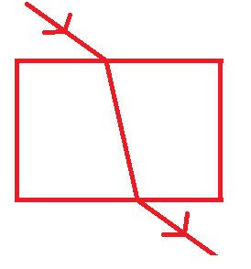
1) When light enters a more optically dense material it slows down and therefore bends towards the normal. The opposite happened when it leaves an optically dense material.

2) A longitudinal wave oscillates parallel to the direction of energy transfer (e.g. sound). A transverse waves oscillated perpendicular to the direction of energy transfer (e.g. light)

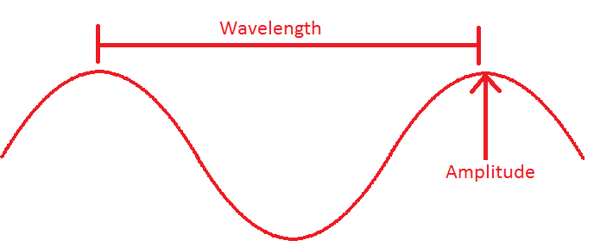
3)
.

