


Pre – Learning Pack
A-Level PE and BTEC Sport

If you are considering either of these options to study at PHS 6th Form, please see some tasks below to help you gain some prior knowledge to the courses.
There are also different tasks that you can begin to complete which will be used in your studies in either PE option in Year 12 onwards.
There is a section for A-Level PE and a different section for BTEC Sport, depending on what option you are considering.

A-level PE
So you want to do A-level PE next year well don’t sit around waiting let’s get ahead of the game…

Throughout the course you will need real sporting examples to ‘show off’ your knowledge and application of the theory, so why not start now building your bank of resources which you can use in lessons, answering exam questions and to secure your understanding.

So with this in mind there are 8 themes we would like you to research and create a fact sheet on. You do not need to do all 8 straight away but to keep you ticking over before we start the course will be good to keep your minds workings.

- Performance enhancing drugs
- Find an athlete who has taken a performance enhancing drug
- What happened?
- Why did they do it?
- What was the consequence?

- Pathway to sporting success
- Find an athlete who has won a gold medal at the Olympic Games and how they were supported through the World Class programme
- What was their pathway to success?

- Violence in sport
- Find an athlete who was punished for being violent in their sport
- What happened?
- Why were they violent?
- What was the consequence?

- Media representation
- Find an athlete who has been negatively represented in the media
- How?
- Why?
- What happened?
- Have they ever been represented in the media in a positive way?

- Modern technology
- Find a sport which has changed dramatically over time by advancements in technology
- What has changed?
- How has it changed?
- What has been the impact on the sport due to technological developments?
- Remember impact can be good or bad!

- Leadership in Sport
- Chose a leader in sport who you feel has been an effective leader
- Why?
- What have been their achievements?
- What characteristics and skills do they have as an effective leader?
- How did they become to be in the leadership role that they hold?

- Global sporting events
- How did politics exploit the Olympic Games in Berlin 1936 and Mexico 1968?
- What happened?
- Are the Olympics used for political gain?
- What other advantages do host nations gain from holding the Olympic Games?
- Are there any disadvantages?
- Use any examples from London 2012 to support your above points

- Anatomy and Physiology
- Find a picture of a sporting image of your choice
- Label all the bones and muscles being used in that movement
- Can you research the individual names of the hamstrings (3) and quadriceps (4)?
- What are the movements happening in the sporting action?
- What is concentric, eccentric and isometric contraction?
- Relate this to your sporting action

Fact sheet tips…
- Use word document
- Pictures/illustrations
- Bullet points – short/sharp facts not lengthy paragraphs
- Colour
- Keep it snappy so you remember them
- Research and read it before you write it
A level PE: Task 2 – EAPI
If you have just completed the GCSE PE in Yr11 the coursework element will still be fresh in your mind. The EAPI is part of the A level course which is similar to that of the written coursework from GCSE. It stands for The Evaluation and Analysis of Performance for Improvement. The task below will be beneficial to help you to prepare.
A big difference of this piece of coursework is that during the actual assessment rather than writing it, you complete it verbally, talking through your answer, demonstrating your knowledge and understanding of your sport.
So with that in mind – complete the following on word – follow the steps and have a go… Save all what you do in a folder!
Step 1 – chose your sport which you want to use for this element of your coursework – it needs to be a sport that you can talk about in detail. Most people chose their practical sport but it doesn’t have to be.
Step 2 – List all the skills needed for your sport
Step 3 – List all the components of fitness needed for your sport
Step 4 – List all the tactics/compositional ideas you would use in your sport
Step 5 – Go on to YouTube and search for a clip in the sport of your choice of performers within a similar age range & ability as you – NOT A PROFESSIONAL. Choose one person to focus on within that clip (most people use someone in the position they play in).
Step 6 – List all of the strengths you see on the clip for your chosen person (for skills, fitness & tactics/compositional ideas). Give a brief reason why each point is a strength.
Step 7 – List all of the weaknesses you see on the clip for your chosen person (for skills, fitness & tactics/compositional ideas). Give a brief reason why each point is a weakness.
Step 8 – Choose one weakness and develop a plan to help the performer improve this weakness. You need to include coaching points and progressive practices like in your GCSE coursework.
There are links below of certain sports to help you or you can find your own but make sure you save the link!
Lacrosse | https://www.youtube.com/watch?v=HWmzMOgSa00
Tennis | https://www.youtube.com/watch?v=983fr2xx2Ww
Swimming | https://www.youtube.com/watch?v=G4QWkhh1KFg
Football | Girls https://www.youtube.com/watch?v=CsGIr1nE7rE  Boys https://www.youtube.com/watch?v=7SlzNSLysks
Netball | https://www.youtube.com/watch?v=KC-_n5IJOxY
Cricket | https://www.youtube.com/watch?v=F5CMIr5QIcA

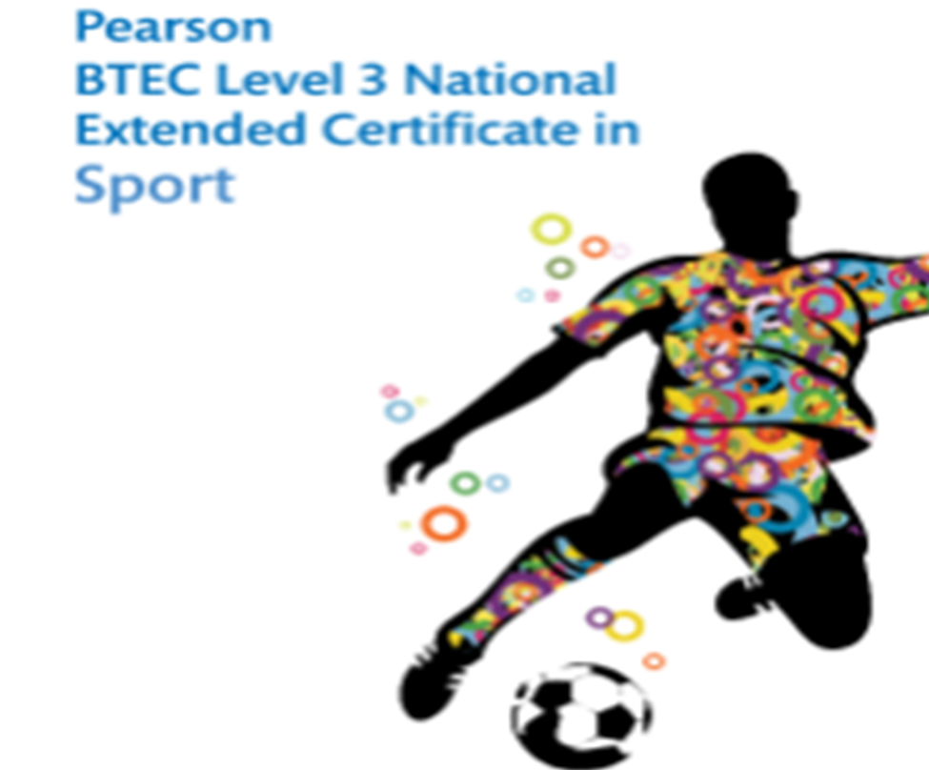

Pre Course Learning Pack

Overview
External Assessments
Accounts for 50% of your overall grade
• Anatomy and Physiology (a written examination)
• Fitness Training and Programming (a case study)
External Assessments are graded either near Pass, Pass, Merit or Distinction.

Internal Units
Accounts for 50% of your overall grade
• Professional development in the sport industry
• Practical sports performance
The Assignments are graded either Pass, Merit or distinction

You can get a detailed course specification from the exam board website
www.qualifications.pearson.com


BTEC Sport - What to watch
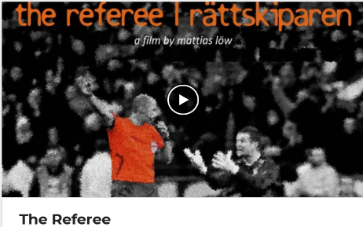
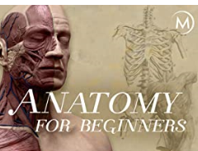



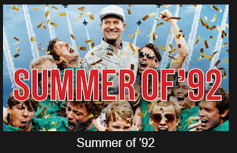




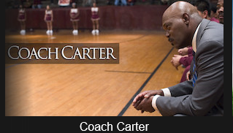
Unit 1: Anatomy and physiology
Can you label the bones a muscles being used in the pictures below
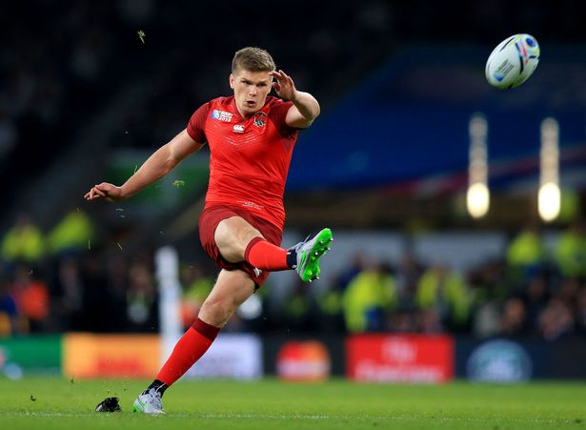
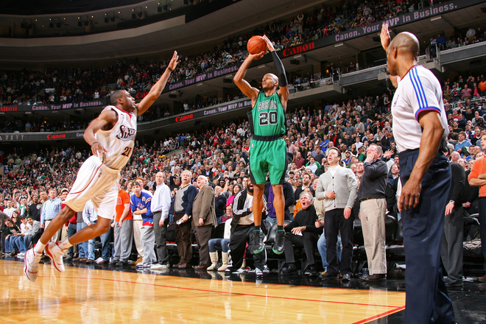

Extension:
Can you name all the muscles in the hamstring (3) and quadriceps (4)?

Can you name the type of movement occurring in the pictures?

Reading list / links
www.humankinetics.com - resources relating to sport and physical activity
www.sportsci.org – sport science: research into sport, including articles on body systems
www.topendsports.com - information on many aspects of anatomy and physiology

Unit 2: Fitness and training methods
Write down your exercise and diet whilst we have been off (or a two week period)

Look at the government recommendations and comment on your diet and exercise in relation to the recommendations

What do you need to improve to meet the diet and exercise recommendations?

Create an exercise plan and diet for a one week period to make sure you meet the recommendations

Reading list / link
www.eis2win.co.uk – nutritional information
www.uksca.org.uk – UK strength and conditioning
www.nhs.uk/livewell - tips for leading a healthy lifestyle
https://www.nhs.uk/live-well/exercise/ - Exercise

Unit 7: Practical sport
Pick your favourite sport / the one you play the most and answer the questions below

- Who is the National Governing Body (NGB) for the sport?

- What are the main rules of the sport?

- What are the main regulations for the sport

- What skills / techniques do you use in the sport?

- What tactics might you use in the sport?

Reading list / link
https://grassroots.fifa.com/en/for-coach-educators/technical-elements-for-grassroots-education/the-basic-techniques/the-basic-techniques.html - Football skills
https://www.bbc.co.uk/bitesize/guides/zqfnycw/revision/1 - Badminton skills
https://www.fiba.basketball/basic-rules - Basketball rules
https://www.lta.org.uk/workforce-venues/officiate-tennis/competition-organiser-resources/rules-regulations/ - Tennis rules
Unit 3: Professional Development in sport
How many jobs in the sport sector can you think of?

Use the internet to research 1 jobs in the sport industry and answer the following questions
Title of the job?

What is the job role and its responsibilities?

What qualifications do you need?

Can you give an example of where you have shown any of the below;
Organisational skills -
Commitment -
Resilience -
Problem solving

Job application process: when you apply for a job there are a number of items you will need to have completed to apply for the job
CV - Update your CV
Letter of application - Write a letter of application for the job you selected above

Reading list / link
http://www.eis2win.co.uk/Pages/Careers_andJobs_at_ EIS.aspx. – Careers in sport
https://careers-in-sport.co.uk/ - Careers in sport
https://www.uksport.gov.uk/jobs-in-sport - Careers in sport
https://www.bases.org.uk/spage-students-careers_centre.html - Careers in sport
https://www.thebalancecareers.com/how-to-write-a-job-application-letter-2061569 - How to write a letter of application

