Welcome to A Level Economics
Complete some of the challenges and activities in this pack to help you prepare for your first year as an economics student! The exam board for A level Economics is AQA. Follow us on twitter at @PHS_Bizecon
Task 1: Get a share bag of chocolate/packet of biscuit/punnet of grapes out. After eating each one, rank out of 10 how more joy each chocolate/biscuit/grape (or substitute) brought you.
Chocolate/biscuit/grape number… | How satisfied did it make me (1 = not at all, 10 = never been happier)
1
2
3
4
5
6
7
8
9
10

Now plot this on a graph.
What do you notice about your satisfaction levels?
Could this be applied to other things you consume? For instance, do you enjoy every day of your time off school the same amount?

Task 2: Excluding the UK (as we’re soon to leave) can you name the other 27 EU member states? - No cheating!!

How many of these countries use the Euro? Which ones?
What currency do the other countries use?
Task 3:
- Who are the 5 richest and 5 poorest countries in the world?
- Select one ‘more economically developed’ country and one ‘less economically developed’ country and prepare a fact file on them – include measures of development e.g. literacy rates, infant mortality rates, economic growth rates. What are the main industries in these countries? What is it like to live there?

Task 4: Inflation is a sustained rise in the average price level. Research your favourite chocolate bar – how much has the price changed over time? What would we expect to happen going forwards? Illustrate this on a line graph.

Task 5: Research the financial crisis of 2007/2008 – what caused this? What was the impact on the UK? What did it mean for businesses and consumers?
Task 6: The government is currently building HS2 – a new rail project that will help people move around the UK quicker. But lots of people are opposed to it being built. Research HS2 and come up with a list of costs and a list of benefits – to what extent do you believe the government should go ahead with this project?

Task 7: Coronavirus
When we consider the UK economy we consider BIGUP. Consider how the economy may be positively and/or negatively impacted.

Balance of Payments (Net Trade = Exports-imports)
Inflation – a sustained rise in the general price level or deflation a sustained fall in prices
Growth – is total income in the economy likely to rise or fall?
Unemployment – what is happening to the number of people employed?
Paying off the National Debt – how much is the government having to spend to combat the crisis and how will they pay for it in the future?

Read through the articles below and consider how the economy may be impacted both negatively and positively:

Extract 1: Economists warn coronavirus pandemic will savage GDP, public finances and employment
The Financial Times, 26th March 2020
The UK economy is plunging into a deeper recession than the 2008-09 financial crisis, according to the most reliable data published so far, with unemployment surging and the public finances sliding sharply into the red because of the coronavirus pandemic. Economists said there was huge uncertainty over the depth of the coming recession and the speed of the subsequent recovery. Some predict the downturn will be short and sharp, but fear that like a decade ago, there will also be a painful transition to a persistently weaker path for economic growth. With most UK households under lockdown, high streets shuttered except for essential stores, and many companies struggling to keep going, large parts of the economy are grinding to a halt. Diane Coyle, professor of public policy economics at Cambridge university’s Bennett Institute, said the interconnected nature of the modern economy meant everyone was affected by the coronavirus crisis.
Cambridge University’s Bennett Institute, said the interconnected nature of the modern economy meant everyone was affected by the coronavirus crisis. “The long list of categories regarded by the UK government as ‘key workers’ is testament to how reliant we are on each other, even within one country,” she added, referring to the government’s list of people such as health and transport workers who are involved in the response to Covid-19 and whose children are still able to attend school.
The downgrades to forecasts as the UK economy has progressively shut up shop are dramatic. Capital Economics thought on March 10 that a pessimistic scenario would be for gross domestic product — the size of the UK economy — to fall from peak to trough by 5 per cent. Exactly one week later, it thought a realistic scenario was a 15 per cent decline. “It’s clear we are in the early days of a big recession,” said Paul Dales, economist at Capital Economics.
Extract 2: Quarter of a trillion set aside for emergency spending by government departments
The Independent, 26th March 2020
Yael Selfin, KPMG’s chief economist, said: “The Covid-19 pandemic is first and foremost a human crisis. A staggering quarter of a trillion pounds has been set aside for emergency spending by government departments as a result of the coronavirus crisis.

Emergency legislation rushed into law last night makes £266bn available for Whitehall departments to spend on “contingencies” over the coming months without getting advance approval from parliament. In a sign of the gigantic impact of the Covid-19 outbreak on the UK’s public finances, the two-clause Contingencies Fund Act increased the total cash available from 2 per cent of normal annual spending – around £10bn – to 50 per cent. The figure – passed with cross-party support – was described as “extraordinary” by the director of the Institute for Fiscal Studies economic think tank Paul Johnson.
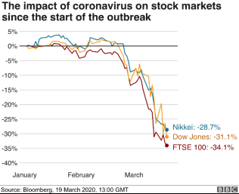
Figure 1:

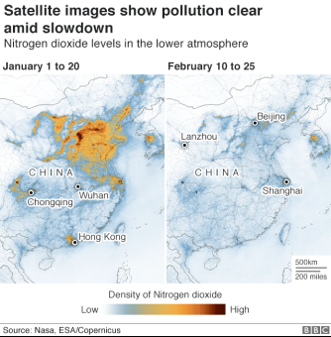
Figure 2

The government is relying on ‘nudge theory’ to help battle the coronavirus.
- What is nudge theory/how does it work?
- What are the pros and cons of using this to help overcome Covid19?

Task 8: In Economics we look at something called externalities. A negative externality occurs when the decision maker makes a decision which has a negative impact on the third party. For example, McDonalds creating supersize meals has a negative impact on the NHS as it can lead to greater health problems for the nation. Can you think of 10 decisions made by businesses of your choice and explain the negative externalities they cause?

Task 9: Research the latest government budget. What areas have they increased spending on? Why do you think this is? What percentage of government money is spent on different areas? What taxes have been introduced/changed/reduced this time round? Why might that be?
Task 10: The sugar tax was introduced in 2018, it taxes drinks with a high percentage of sugar.
- What is the rate of tax for the sugar tax?
- Assess the arguments for and against expanding this tax further and taxing sweets, chocolate and other sugary food items.

Task 11: Many countries suffer from regional inequalities, the UK and Italy are just two key examples of this.
Create a fact file for Italy explaining:
- Why the North/south divide there has come about
- How the government has tried to combat it so far
- Why it is a problem to have a north/south divide in the country
- Any other ideas you have to reduce the north/south divide going forwards

Task 12: There are many different types of market a business can operate in, create a definitions list for the following, and then find 3 examples of different businesses/industries that fit into each one:
Monopoly
Duopoly
Oligopoly
Monopolistic
Perfect competition

Task 13:
- Find the following definitions: Trading bloc, international trade, multinational company, exchange rates, exports, imports, foreign direct investment, and balance of payments.

- Find out who is in each trading bloc and label them on the map below – ASEAN, EU, NAFTA, SAFTA, COMESA

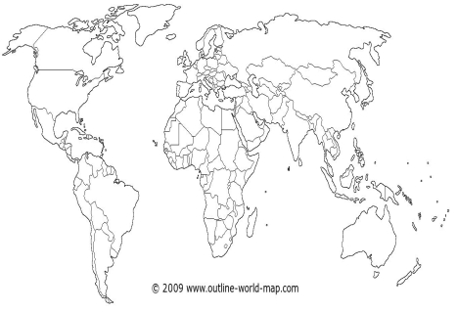

- What is globalisation?
- What are the advantages and disadvantages of globalisation?

Task 14: Priming is when our behaviour is by cues that work subconsciously and prime us to behave / choose in certain ways. E.g. playing certain types of music in shopping centres.
- Why do businesses choose to use priming?
- Can you find 3 other examples of behavioural priming?

Task 15: During the coronavirus, the airline industry has virtually ground to a halt, with many holidays being cancelled and companies grounding their fleets.
Using the following article: https://www.economist.com/business/2020/03/15/coronavirus-is-grounding-the-worlds-airlines and your own knowledge explain:
- What are the economic impacts of airline industries going bust? (You can use the cases of Flybe and Thomas cook to help you here!)
- Do you believe the government should intervene and bail out the airlines? Explain your reasons for and against.
- The airline industry has ‘high barriers to entry and exit’ what does this mean?

Task 16: Health economics
1. The NHS should be privatised. Debate the reasons for and against this statement.
- The government prescription charge is £9 per item. There are some exemptions for this, for example children under 18 don’t pay. Debate the following arguments:
- Prescription charges should be abolished for everyone.
- We should not have exemptions. Everyone should pay prescription charges, meaning they could be charged at a much lower rate (e.g. £1 rather than £9).

Task 17: Pick 3 PLC’s of your choice that can be found on the FTSE 100 (London stock exchange), follow what happens to their share price over the coming months. What causes them to increase? What causes them to decline? When do the significant high points/low points occur?

Things to watch | Things to read
The big short  Dirty money (Netflix)  Explained (Netflix)  Lehman brothers: The bank that bust the world.  The news | The Economics book – Dorling Kindersley  Freakonomics - Stephen J. Dubner and Steven Levitt  50 Economics ideas – Edmund Conway  The Economist magazine (can be found online)  Sky news/The Guardian/BBC news

Other:
- There are lots of free stock market games you can play online to get an insight into financial markets – join with your friends and see who can win!
- Keep an eye on the news for things like changes in interest rates/recessions/government spending and tax changes over the next few months
- Tutor2u are launching introductory modules on their website from May for different areas of economics – have a browse and complete any of interest.
- Finally, if you have any questions about the course, please don’t hesitate to get in touch – we look forward to meeting you in year 12!

