
Business at Poynton 6th Form

Getting ready for A Level and BTEC Business

If you are thinking of studying Business at Poynton Sixth Form, there are a number of tasks you can do to prepare yourself.

If you have studied Business before you may recognise some of these key terms. Make a list of these key terms and simple definitions. These terms are the basics of business language.

- Revenue
- Costs
- Profit
- Fixed costs
- Variable costs
- Breakeven point
- Shareholder
- Stakeholder
- Marketing
- Market share
- Brand loyalty
- Unique selling point (USP)
- Market research

- Fiscal policy
- Monetary policy
- Market research
- Private sector
- Public sector
- Merit goods
- Perfect competition
- Oligopoly
- Monopoly
- Zero-hour contracts
- Hot-desking

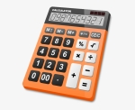
Learn your formulas!

There are a number of formulas that you will need to know. If you start learning them now, you will be able to focus more on analysing what they mean.
Some of these include:

- Revenue
- Total costs
- Profit
- Breakeven
- Market share
- Unit costs
- Contribution per unit
- Gross profit
- Net profit
- Total contribution



- Start work on a Business Scrap Book. Print and stick in short business articles (or the opening 2 or 3 paragraphs of a longer one) or the date and 5 key pieces of information. Articles could relate to a specific business, an industry or the UK economy as a whole and shouldn’t be more than 5 years old. Aim to collect 1-2 articles per week on a range of topics including marketing, new products, failed products, employee problems, motivation, training, just in time, stock issues, becoming a public limited company, awards, new production methods, moving abroad, new technology, redundancies or restructuring.

- Research the financial crisis of 2007-8.

- Why did it happen?
- What happened?
- How did it impact the population of the UK?
- How did it impact businesses in the UK? Which businesses suffered in particular? Which businesses went into liquidation? Did any businesses do well?

- What is inflation? What are interest rates? What are exchange rates? What is GDP? Why does the government change these things? How do they impact consumers and businesses?

- Research a business(es). Produce a PowerPoint that gives information about when it was set up and by who, the type of ownership structure it has, how many stores and how many countries it operates it, how it markets its products through advertising and other methods, how many staff it has, how many different products and services it has, its most recent product launch, the current leader and any previous famous leaders, how it acts in an ethical way and how it adapts its products to suit different countries.

- Research how the world of business is being impacted by Covid-19. You could research the following:

- Healthcare
- Supermarkets
- Self-employed
- Holiday companies
- Unemployment/benefits
- Pubs, bars, restaurants etc
You can find articles and use them create a powerpoint, draw a timeline of key events or create a mindmap.
- Research the following “top 10s” – add some detail to justify their place in the list:
  - Most valuable global brands
  - Best places to work in the UK
  - Most innovative companies in the world
  - Mergers and takeovers of all time
  - Best business leaders
  - Online retailers
  - Largest economies in the world

- Ethics are becoming more and more important. Research an ethical and an unethical company and prepare a presentation to show how they have made ethical/unethical decisions. What are the benefits of acting ethically?

- Produce a profile of a famous business leader. This can be from any industry: technology, sport, retail, online, entrepreneur.

- What are the current minimum wages for each of the age ranges? How does this compare with other countries? Find 5 other examples of minimum wage levels from around the world. Does every country have a minimum wage? Why do some countries have a minimum wage? Do you think we should?

- What is the stock market? What is a share? Choose 5-10 companies and find out the price of their shares. Check on their shares each week and note down the price for a minimum of 6 weeks, would you have lost/gained money if you had purchased them?

Company | 20/4 | 27/4 | 4/5 | 11/5 | 18/5 | 25/5 | 1/6
Apple
Tesco

- Sometimes businesses make adverts that receive complaints and are removed. Find out more about the ASA. What is their role? What are the rules about advertising? Find some examples of adverts that have been banned and explain why.

- Make sure you have an up to date CV. You should include your qualifications, extracurricular activities and achievements and previous job experience (if you have any).


Debate the key issues:

There are some important decisions that businesses have to make. These decisions make interesting debates for business students. Jot down at least 3 ideas to support both sides of the following debates.

- Ethical options should only be considered if they will make the business more profit.
- The most successful business is the one who makes the most profit.
- Happy employees are the key to business success.
- A business should get its raw materials for wherever it can find them the cheapest.
- Customers expect businesses to lie in their advertising, so all businesses may as well do it.
- The responsibility for the success of a business lies with the owner.
- The government should get involved in business.
- The NHS should remain in the public sector.

Branding Challenge
How do companies add value to simple products?

Bottled water companies convince is to pay for something we can get for free out of the tap (if we’re not the person that pays the water bill!)

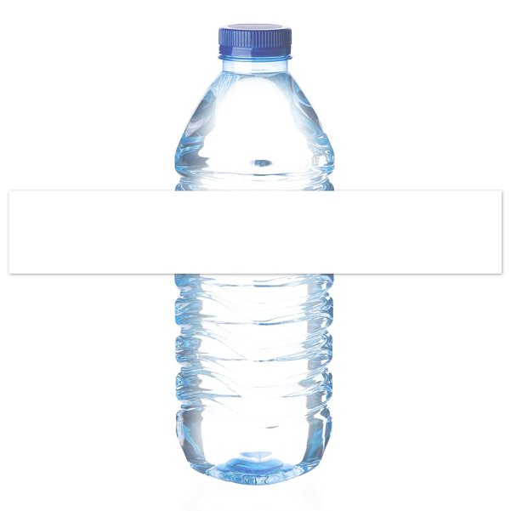
Design a label for a new bottled water that would stand out from the rest of the bottles of water in the fridge and answer the following questions:

- What is the brand name?
- What is your USP (unique selling point)?
- What is your selling price?
- Who is your target market?
Have a go at the following maths questions. You will need to keep practising your maths skills to ensure you can cope with the numerical aspects of both the A Level and Business course.

Q1 | Balti Towers is an Indian takeaway that also offer a delivery service. Last year, the business delivered 1,400 curries. This year, the owner estimates that they will deliver 1,512 curries.  Calculate the estimated percentage increase curry deliveries.
Your workings:

Q2 | School of Choc is a confectionary manufacturer located in County Durham. The business employs 120 staff. The ratio of male to female staff is 2:3.  Calculate how many female staff School of Choc employs.
Your workings:

Q3 | Jimmy Chews is a sweet shop located in Wetherby. This year, the owner estimates that the business, which also sells soft drinks, will sell 3,360 cans of coca cola, 5% more than last year.  Calculate how many cans of coca cola Jimmy Chews sold last year.
Your workings:

Q4 | Bubblicious is a hot tub manufacturer located in Chester. Their hot tubs retail for £4,500. The manufacturing cost per hot tub is 2/5 of the selling price.  Calculate the cost of manufacturing one hot tub.
Your workings:

Q5 | The chart below shows the number of hot tubs Bubblicious sold between 2014 and 2017. The owner estimates that in 2018, hot tub sales will be 5% lower than in 2017.  Calculate the average annual sales of hot tubs between 2014 and 2018.  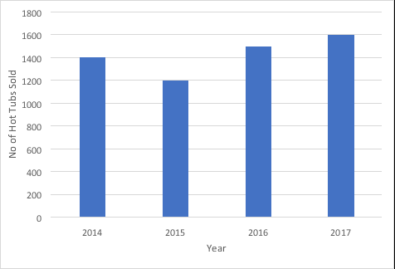
Your workings:

Q6 | Melchester Rovers Football Club can seat 42,000 spectators. Last week, when they played Harrogate Town, there were 36,960 spectators.  Calculate the percentage of empty seats.
Your workings:

Q7 | A family of four, on holiday in the UK from Spain, visited the ‘Whale of a Time’ sea life centre in London. The total entrance cost for the family was £90.  Assuming an exchange rate of £1: €1.08, calculate the total entrance cost in Euros.
Your workings:

Q8 | Loft in Space, a manufacturer of loft insulation, took 80 of its employees on a two-day team building trip to an outdoor activity centre in the Lake District. The total cost of the trip was £9,600. The accommodation cost per employee was 3/5 of the total cost per employee.  Calculate the accommodation cost per employee.
Your workings:

Q9 | Tea-Total is a café in Cumbria. Below is a pie chart showing the percentage of drinks purchased for a group of 200 customers.  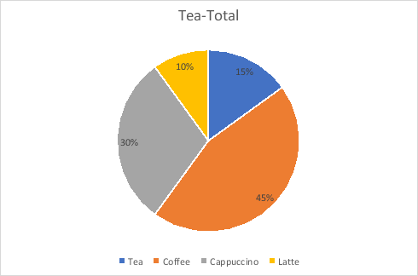  (A) Calculate how many customers purchased a coffee  (B) Calculate how many customers did not purchase a tea  (C) Calculate the fraction of customers that purchased a Latte
Your workings:

Q10 | Graham Riley is an employee of Father Treads, a business that specialises in car tyres. Graham attends a meeting at Head Office, travelling 60 kilometres each way. Graham is entitled to claim travel expenses at 45p per mile.  Based on the assumption that 10 kilometres is equivalent to 6 miles (approximately), calculate how much Graham is entitled to claim.
Your workings:

Q11 | Car-tastrophe is a car showroom based in Stanhope. The business consists of one manager and 3 salesman, Jim, Jon and Joseph. Each month, a sum of money is paid as a bonus and is divided in the ratio of the number of cars each salesman has sold. Jim sold 7 cars, Jon sold 8 cars and Joseph sold 9 cars. Joseph received £1,125  Calculate how much money Jim and Jon received.
Your workings:

Q12 | Barber Streisand is a hair dressing salon located in Sunderland. The owner Barbara, recently introduced a new system of rewarding her staff. At the end of the week, Barbara puts the following in a bag:  5 x £10 notes  4 x £20 notes  3 x £50 notes  At the end of the week, the hairdresser who has provided the best service can select a note from the bag as a reward.  Calculate the probability of not selecting a £10 note.
Your workings:

Q13 | Frame, Set and Match is a picture framing business with several shops across the North East of England. The business has a total of 90 employees, of which 54 are female.  Calculate, in the lowest possible terms, what fraction of the total employees are male.
Your workings:

Q14 | Wooden it be Lovely is a small manufacturer of wooden children’s toys. Last week, the business produced 32,000 toys, of which 40% were checked for quality. Of the 40% checked, 1/5 had a defect.  Calculate how many wooden toys were found to not have a defect.
Your workings:

Q15 | Sparked Out is a retailer of electrical products located in County Durham. The owner, Joseph Sparks, is analysing the sales figures of two product lines, the Lavazza coffee machine and the Breville toaster.  In 2017, the total value of Lavazza coffee machine sales was £12,100 whilst the total value of Breville toaster sales was £5,292. Joseph noticed that the sales of Lavazza coffee machines have been increasing by 10% per year, whilst sales of Breville toasters have been increasing by 5% per year, over the last two years.  Calculate the total sales value of Lavazza coffee machine sales and Breville toasters in 2015.
Your workings:

Watch list

- Dragons Den on iPlayer
- The Apprentice on iPlayer
- Can We Trust Huawei?
- Can You Trust The Billion Pound Investors?
- Spying on the Scammers
- The Truth about Starbucks and Nespresso
- Celebs for Sale: The Great Charity Scandal
- The Secrets of Amazon
- Britain’s New Build Scandal
- How To Lose 7 Billion Pounds
- The Truth About Your Pay
- Undercover: Britain’s Cheap Clothes
- Amazon – What they know about us
- Dirty Money (Netflix)
- Rotten (Netflix)
- The nine to five with Stacey Dooley
- Aldi vs Lidl: Supermarket wars
- The Lorax
- A Very British Hotel
- Thomas Cook: Rise and Fall of Britain’s Oldest Travel Agent
- Inside Facebook: Secrets of a Social Network
- The Restaurant That Makes Mistakes
- How To Stop Your Nuisance Calls
- The Truth About Your Pay
- Mary Portas: Secret Shopper
- The Job Interview

