GCSE Mathematics
Year 10 – Information for Parents 2021/22

GCSE Mathematics | AQA Mathematics (8300)

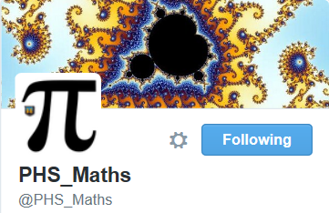
All students will take their Maths GCSE examinations in the summer of 2023.
Details for the GCSE course can be found at:
http://www.aqa.org.uk/subjects/mathematics/gcse/mathematics-8300
There are a total of 3 1hr30 exam papers for the GCSE course. (1 non calc and 2 calc).

How can I help my child with their Maths?
All students are set homework tasks on a regular basis. In addition to supporting your son or daughter with this work, there are other ways that you can help your child to succeed in Maths.
- Practice papers, past papers, mark schemes and solutions will all be available to the students through Google Classroom. While the students have not yet covered all the content for the course, they should use these to gain an understanding of the demand of questions expected of them next Summer.
- Students should be set SMART homework tasks where their teacher has identified areas for improvement have been identified.
- Please make sure they check their google classroom task list on a regular basis and complete the tasks that have been set.
- All our written home learning tasks will be set via google classroom. This means that if they miss a lesson that home learning is set they can always complete the work.
- Students will also have access to drfrostmaths.com. Students will be given this information my their class teacher. This website will be used to set one of their fortnightly homeworks.
- If they have purchased a revision guide or workbook, encourage them to use these on a regular basis to support the work that they are covering in lessons.
Useful Websites:
www.aqa.org.uk
www.drfrostmaths.com
http://corbettmaths.com
www.bbc.co.uk/bitesize

- Use Youtube – there are a lot of useful video clips for Maths revision on here.
- Ensure that they have the equipment that they need – they will be using their calculators, rulers, protractors and compasses in lessons as well as in the exams.
- Students will be sitting a formal assessment every half term, compiled of past GCSE questions to help prepare students for their GCSE.
Useful revision material and websites:
We are able to order revision guides at a discounted rate. These will be available to order in year 11 through the ParentPay platform.
Higher: AQA GCSE Maths Higher Tier All-in-One Revision: ISBN 978-0008112509
Foundation: AQA GCSE Maths Foundation Tier All-in-One Revision: ISBN 978-0008112516

