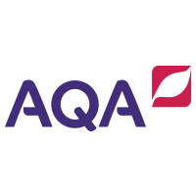
GCSE English Language and Literature
Year 11 Information Evening 2021
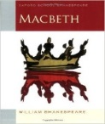
English Language:
Paper 1
20th Century Literature reading
Creative writing
Paper 2
19th Century and 21st Century reading
Transactional writing
100% Examination
English Literature:
Paper 1
Macbeth
The Strange Case of Dr. Jekyll and Mr. Hyde?
Paper 2
An Inspector Calls
Power and Conflict poetry
Unseen poetry
100% Examination

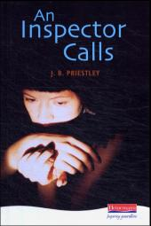

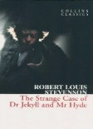

 | HT1 | HT2 | HT3 | HT4 | HT5
English Language | Language and Representation | Whole Paper 1&2 Revision | Writing Focus: Paper 1 Q5 | Writers’ Attitudes: P2 Q4/5 | Whole Paper Revision
English Literature | Paper 2 Revision | Jekyll and Hyde? | Macbeth | Paper 1 Revision | Paper 2 Revision
This is a common course timeline for all teachers although there will be variations in approach to suit particular groups.
How can I help my child study English at home?
All students receive regular home revision tasks via Google Classroom but there are also ways that you can help your child succeed in English.
- Follow us on Twitter to gain access to useful activities: @PHS_EngDept
- Encourage your child to attend our Supported Study sessions from Spring
- Talk to them about their Centralised Home Learning on a regular basis and check their folders.
- Discuss language at every opportunity. Ask them what they think about word choices on TV, in newspapers, in conversations that they’ve participated in etc.
- Let them see you reading
- Encourage them to read a range of fiction and non-fiction texts including a broadsheet newspaper on a regular basis
- Read the literature texts and discuss them together.
- Encourage them to read the GCSE texts more than once.
- Talk to them about plot, character and themes; ask them to explain their ideas to you.
- Rent the films and talk about the differences between the book/drama and the film version
- Discuss characterisations, settings, and themes of TV shows and films that you have enjoyed together
- Support them in creating a study timetable.
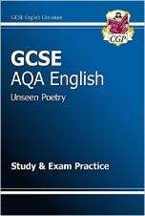
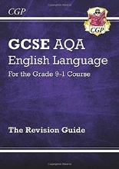
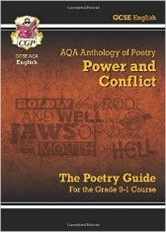
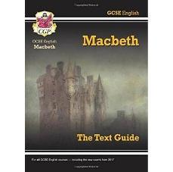
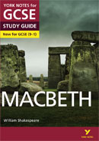
- Test them on their revision notes.
Useful revision guides:

