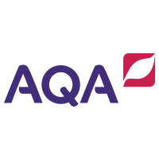
GCSE English Language and Literature
Year 10 Information Evening 2021
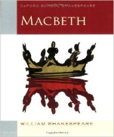
English Literature:
Paper 1
‘Macbeth’
‘The Strange Case of Dr. Jekyll and Mr. Hyde’
Paper 2
‘An Inspector Calls’
Power and Conflict poetry
Unseen poetry

100% Examination

English Language:
Paper 1
20th Century Literature reading
Creative writing
Paper 2
19th Century and 21st Century reading
Transactional writing

100% Examination

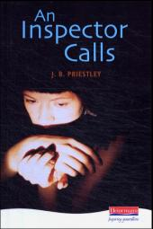

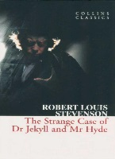

 | HT1 | HT2 | HT3 | HT4 | HT5 | HT6
English Language | Written Language Investigation | Writers’ Method Inquiry | Spoken Language Investigation | Other Worlds | Wider Reading and Writing – Whole Texts
English Literature | Power and Conflict Poetry | Macbeth | Power and Conflict Poetry | An Inspector Calls | Paper 2 Revision | Jekyll and Hyde
English Language and English Literature are now timetabled as individual subjects. Students receive 2 GCSEs for their efforts. This is a common course structure for all teachers although there will be variations in approach to suit particular groups.
How can I help my child study English at home?
All students receive regular revision task via Google Classroom but there are also ways that you can help your child succeed in English.
- Follow us on Twitter to gain access to useful activities: @PHS_EngDept
- Talk to them about their Centralised Revision on a regular basis.
- Discuss language at every opportunity. Ask them what they think about word choices on TV, in newspapers, in conversations that they’ve participated in etc.
- Let them see you reading.
- Encourage them to read a range of fiction and non-fiction texts including a broadsheet newspaper on a regular basis.
- Read the literature texts and discuss them together.
- Encourage them to read the GCSE texts more than once.
- Talk to them about characters and themes; ask them to explain their ideas to you.
- Rent the films and talk about the differences between the book/drama and the film version
- Discuss characterisations, settings, and themes of TV shows and films that you have enjoyed together
- Support them in creating a study timetable.
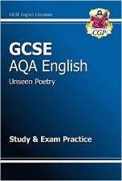
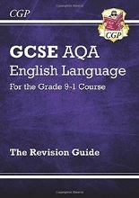
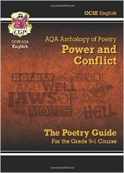
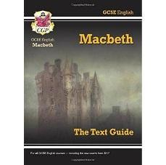
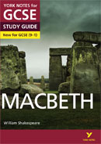
- Test them on their revision notes.
Useful revision guides:

