What will I learn?
The Scheme of Learning for Year 7 to 11 is in transition to be based on the Sparx Curriculum. At current, Year 7 and 8 are following this scheme and it will continue to be rolled out each year. Year 9 to 11 are continuing to follow the White Rose Maths Scheme of Learning. The content for all groups is based upon these schemes.
Here is the Sparx scheme of learning for Year 7 & 8:

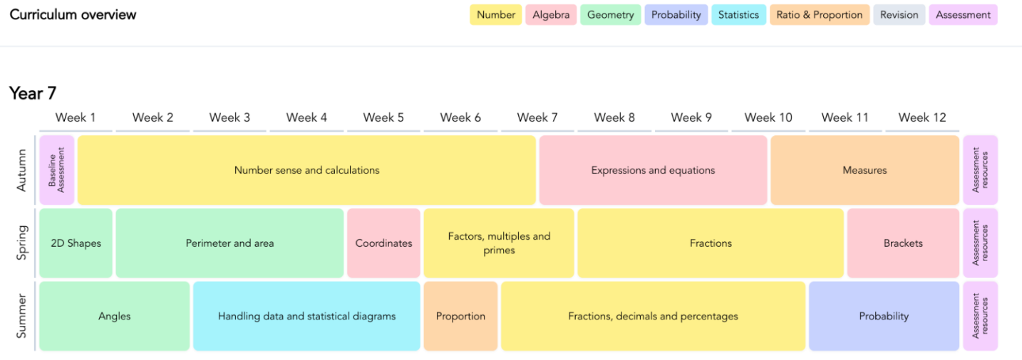

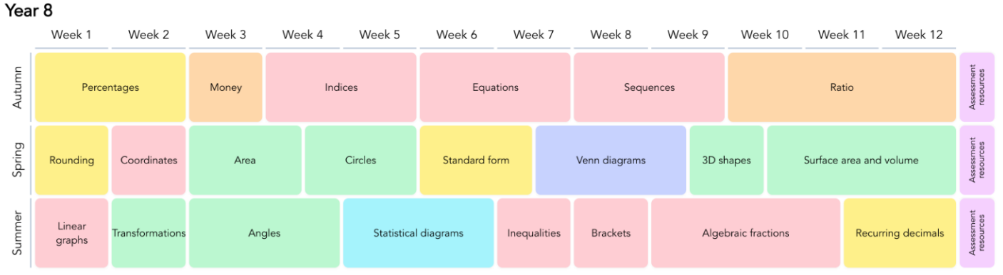

Here is the White Rose Maths scheme of learning for Year 9 to 11:
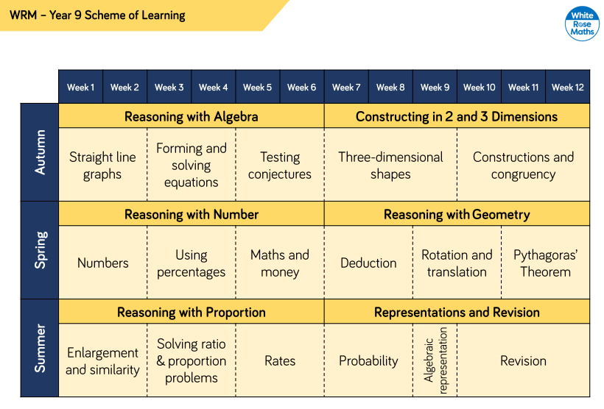
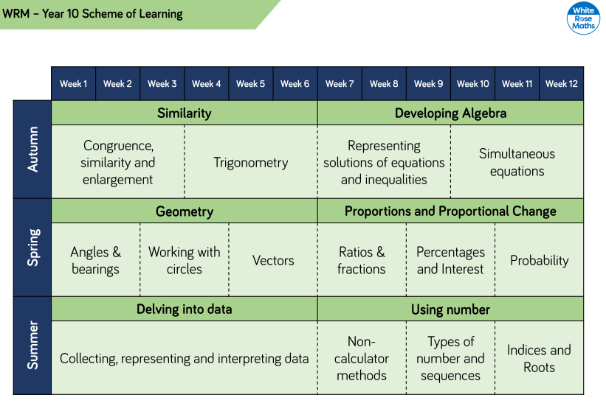
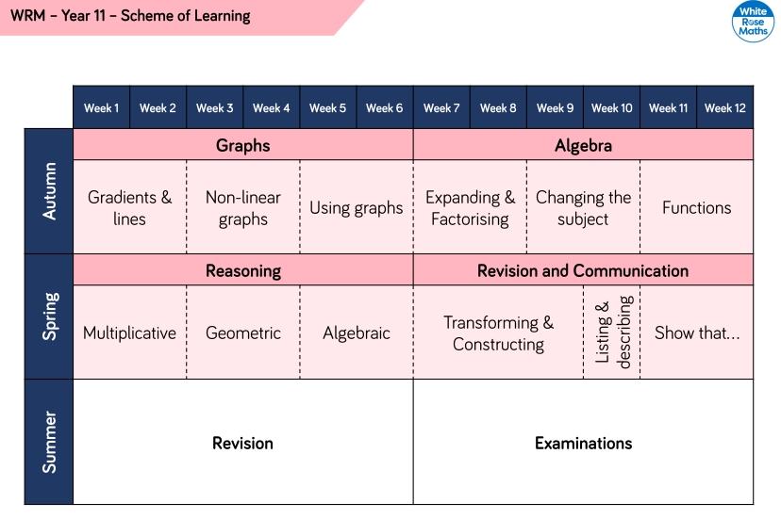
Please note – Some of the Year 11 topics are taught at the end of year 10 to give additional time for revision before the GCSE examinations take place in year 11.
Some of our year 11 students study Extended Maths which is a qualification taken in addition to GCSE Maths.

How will I learn it?
The Poynton High School Mathematics department have developed a shared approach to planning lessons. This is to help develop consistency, ensure high quality resources are used and develop common teaching approaches to certain skills within the curriculum. Lessons begin with a starter, this can be a retrieval practice activity on mixed topics the students have previously been taught. Other times this may be a puzzle style problem using a skill they have learnt recently.
Lessons follow a pattern where students discover or are introduced to a new topic. Once they have grasped the basics, we begin to formalise the method and allow time for some deliberate practice. Once they are beginning to master a topic, lessons are enriched with some less structured problems or puzzles to really push the understanding!
Our teaching staff believe learners of all attainment need to experience early success within a topic before the understanding is further enriched. By employing techniques such as silent teacher demonstrations and deliberate practice, we have found our students to make deeper connections within and between the areas they are learning. We use visual modelling strategies such as bar modelling, ratio tables, and algebra tiles as they can help visualise a broad range of mathematical ideas using frameworks that are familiar to the students already.
At Poynton High School we believe the purpose of assessment should be to help progress learning. We use data to inform us of the starting points for students within a class. We also employ more informal, low stakes qualitative assessment strategies as a regular part of our lessons. We value the use of well written multiple-choice questions to help really draw out and address misconceptions in the students understanding. Students regularly review their own written classwork through peer book reviews and are rewarded for presenting their work in a mathematically clear and fluent format.
Assessments | Students have a series of assessments per year as an opportunity to learn and practice previously taught skills and techniques.  Formal  Used to determine students’ individual strengths and weaknesses and make judgements on attainment. Afterwards, a detailed analysis is completed and strengths and targets are highlighted. Teachers then use this knowledge to progress students. These assessments usually cover content from the previous term to help with  Open Book  We use this type of assessment to help our students develop their exam technique. Students are encouraged to keep clear and well organised book notes within lessons as they will be able to use these as an aid in these assessments. These assessments usually cover recently studied topics.
Home Learning | Students are given a weekly online homework task on Sparx Maths. This is an online learning platform that creates personalised maths homework for students. The topics on the homework correspond to the curriculum being taught to allow for independent practice following teaching in lessons. Part of every homework will also include topics from a while ago to act as constant retrieval practice. Sparx uses artificial intelligence to build a personalised set of questions to match your young person’s current level of understanding.  Our aim is for all children to strive for 100% completion of their homework.  By consistently using Sparx Maths, your child can build a solid foundation in maths and achieve their full potential.
Stretch and Challenge | For our more able students, we give them an opportunity to take part in events such as the National UKMT Maths Challenge competition.

