

Yr6 to Yr7
Poynton High School

MFL Transition booklet
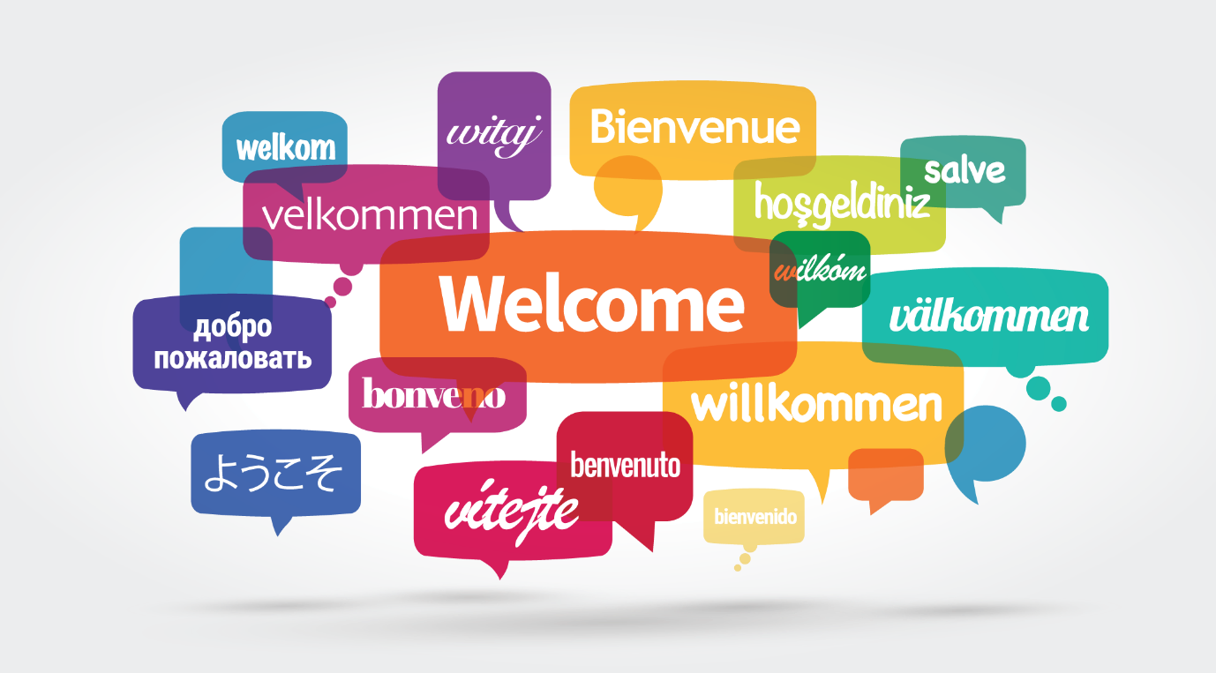

Full name:

Primary school:

What do you think is meant by the following quotes? Explain your answer


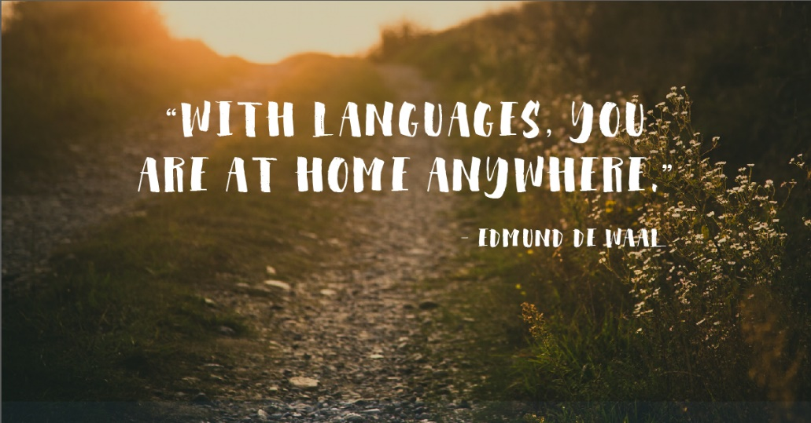

Do you think it is important for people to learn other languages? Explain your answer

What do you think are the benefits of learning a language?

Create a mindmap showing the opportunities that learning languages could bring or create?
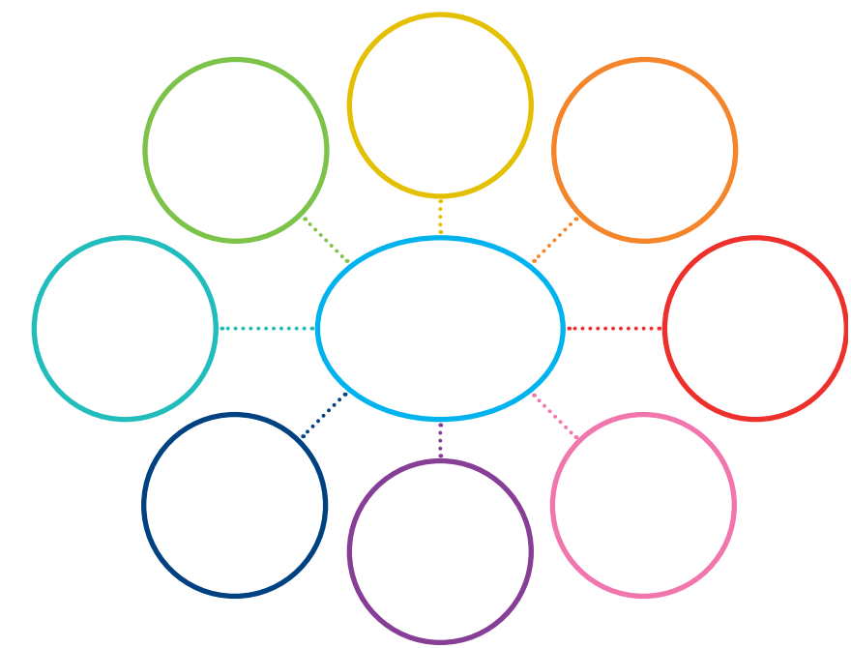
Opportunities brought by learning a language



What language or languages have you studied at primary?

Can you speak any other languages at home? If yes, which one(s) and how much (spoken only, written etc…)?

Have you enjoyed learning languages at primary? Explain your answer

What was the favourite thing you have learned in another language in
Primary school? Why?


Use this page to show us ANYTHING you have learned from ANY foreign languages in Primary school. This could be words you remember, a sentence or paragraph that shows your knowledge or something even more creative to show what you already know! REWARD POINTS FOR QUALITY AND CREATIVITY !

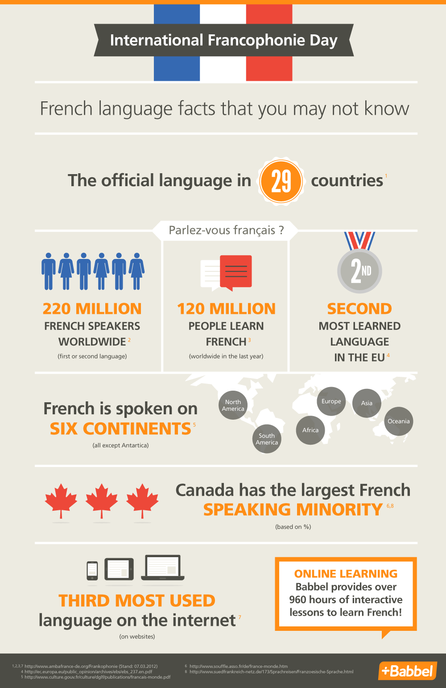

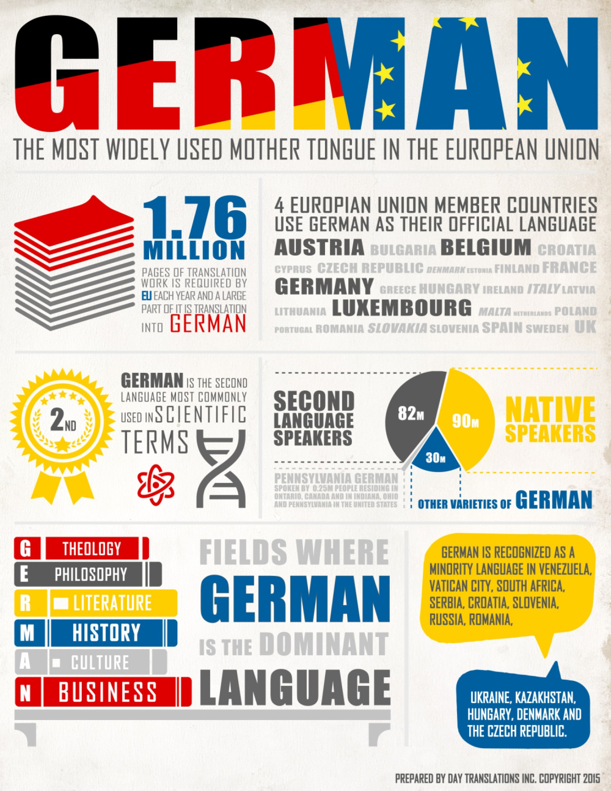

Now you know some interesting facts about the French and German languages, it is your challenge to create your own Fact Sheet on a country where they speak French or German.Things you may consider…

- Food (La nourriture / Essen)
- Festivals (Les fêtes / Feste)
- Culture (La culture / Kultur)
- Music (La musique / Musik)
- Famous people. (Les célébrités/ bekannte Leute)
- Monuments (Les monuments/ Denkmäle)
- Anything else of interest! ( en plus / noch etwas)

REWARD POINTS WILL BE AWARDED FOR quality and creativity…

We really look forward to seeing your work which will help your MFL teacher(s) get to know you and will share the best pieces at the high school and on social media.

